

Project Report on

**SecureCloud**

**Submitted by**

**Kuldeep Roy (230944223017)**

**Chirag Patil (230944223009)**

**Dinesh Sarode (230944223035)**

**Tushar More (230944223019)**

Under the guidance of

**Mr. Manu Zacharia**

**Mr. Nisarg Acharya**

**Mr. Sandeep Walvekar**

**Mr. Amit Kulkarni**

**In partial fulfillment of the award of Post Graduate Diploma in**

**IT Infrastructure, Systems and Security**

**(PG-DITISS)**



**Sunbeam Institute of Information Technology,**

**Pune (Maharashtra)**

**PG-DITISS -2024**

**DECLARATION**

We declare that this written submission represents our ideas in our own words and where others ideas or words have been included; we have adequately cited and referenced the original sources. We also declare that we have adhered to all principles of academic honesty and integrity and have not misrepresented or fabricated or falsified any idea/data/fact/source in our submission. We understand that any violation of the above will cause for disciplinary action by the Institute and can also evoke penal action from the sources which have thus not been properly cited or from whom proper permission has not been taken when needed.

Place: Pune

Date: 22/02/2024

**Kuldeep Roy Chirag Patil Dinesh Sarode Tushar More**

**(230944223017) (230944223009) (230944223035) (230944223019)**

**CERTIFICATE**

This is to certify that the project report entitled **“SecureCloud”**, submitted by **Kuldeep Roy** is the bonafide work completed under our supervision and guidance in partial fulfillment for the award of Post Graduate Diploma in IT Infrastructure, Systems and Security (PG-DITISS) of Sunbeam Institute of Information Technology, Pune (M.S.).

Place: Pune

Date: 22/02/2024

**Mr. Sandeep Walvekar Mr. Vishal Salunkhe**

Guide Course Coordinator

**Mr. Nitin Kudale**

CEO

Sunbeam Institute of Information Technology

Pune (M.S.) – 411057

**CERTIFICATE**

This is to certify that the project report entitled **“SecureCloud”**, submitted by **Chiraag Patil** is the bonafide work completed under our supervision and guidance in partial fulfillment for the award of Post Graduate Diploma in IT Infrastructure, Systems and Security (PG-DITISS) of Sunbeam Institute of Information Technology, Pune (M.S.).

Place: Pune

Date: 22/02/2024

**Mr. Sandeep Walvekar Mr. Vishal Salunkhe**

Guide Course Coordinator

**Mr. Nitin Kudale**

CEO

Sunbeam Institute of Information Technology

Pune (M.S.) – 411057

**CERTIFICATE**

This is to certify that the project report entitled **“SecureCloud”**, submitted by **Dinesh Sarode** is the bonafide work completed under our supervision and guidance in partial fulfillment for the award of Post Graduate Diploma in IT Infrastructure, Systems and Security (PG-DITISS) of Sunbeam Institute of Information Technology, Pune (M.S.).

Place: Pune

Date: 22/02/2024

**Mr. Sandeep Walvekar Mr. Vishal Salunkhe**

Guide Course Coordinator

**Mr. Nitin Kudale**

CEO

Sunbeam Institute of Information Technology

Pune (M.S.) – 411057

**CERTIFICATE**

This is to certify that the project report entitled **“SecureCloud”**, submitted by **Tushar More** is the bonafide work completed under our supervision and guidance in partial fulfillment for the award of Post Graduate Diploma in IT Infrastructure, Systems and Security (PG-DITISS) of Sunbeam Institute of Information Technology, Pune (M.S.).

Place: Pune

Date: 22/02/2024

**Mr. Sandeep Walvekar Mr. Vishal Salunkhe**

Guide Course Coordinator

**Mr. Nitin Kudale**

CEO

Sunbeam Institute of Information Technology

**Pune (M.S.) – 411057**

**APPROVAL CERTIFICATE**

This Project II report entitled **“SecureCloud”** by **Chiraag Patil (230944223009)** is approved for Post Graduate Diploma in IT Infrastructure, Systems and Security (PG-DITISS) of Sunbeam Institute of Information Technology, Pune (M.S.).

Place: Pune

Date: 22/02/2024

Examiner: 

**(Signature)**



**(Name)**

**APPROVAL CERTIFICATE**

This Project II report entitled **“SecureCloud”** by **Dinesh Sarode (230944223035)** is approved for Post Graduate Diploma in IT Infrastructure, Systems and Security (PG-DITISS) of Sunbeam Institute of Information Technology, Pune (M.S.).

Place: Pune

Date: 22/02/2024

Examiner: 

**(Signature)**



**(Name)**

**APPROVAL CERTIFICATE**

This Project II report entitled **“SecureCloud”** by **Tushar More (230944223019)** is approved for Post Graduate Diploma in IT Infrastructure, Systems and Security (PG-DITISS) of Sunbeam Institute of Information Technology, Pune (M.S.).

Place: Pune

Date: 22/02/2024

Examiner: 

**(Signature)**



**(Name)**

**APPROVAL CERTIFICATE**

This Project II report entitled **“SecureCloud”** by **Kuldeep Roy (230944223017)** is approved for Post Graduate Diploma in IT Infrastructure, Systems and Security (PG-DITISS) of Sunbeam Institute of Information Technology, Pune (M.S.).

Place: Pune

Date: 22/02/2024

Examiner: 

**(Signature)**



**(Name)**

**CONTENTS**

| **TITLE** | **PAGE NO** |
| --- | --- |
| **Declaration** |  |
| **Certificate** |  |
| **Approval Certificate** |  |
| **Abstract** | i |
| **1. INTRODUCION** | 1 |
| **LITERATURE SURVEY** | 2 |
| **2. DOCKER** | 3 |
| 2.1 DESCRIPTION | 3 |
| 2.2 ADVANTAGES | 3 |
| **3. TRIVY** | 5 |
| 3.1 DESCRIPTION | 5 |
| 3.2 ADVANTAGES | 5 |
| **4. SONARQUBE** | 7 |
| 4.1 DESCRIPTION | 7 |
| 4.2 ADVANTAGES | 7 |
| **5. OWASP DEPENDENCY CHECK** | 9 |
| 5.1 DESCRIPTION | 9 |
| 5.2 ADVANTAGES | 9 |
| **6. NPM** | 11 |
| 6.1 DESCRIPTION | 11 |
| 6.2 ADVANTAGES | 11 |
| **7. JENKINS** | 13 |
| 7.1 DESCRIPTION | 13 |
| 7.2 ADVANTAGES | 13 |
| **8. PROMETHIUS** | 15 |
| 8.1 DESCRIPTION | 15 |
| 8.2 ADVANTAGES | 15 |
| **9. ARGOCD** | 17 |
| 9.1 DESCRIPTION | 17 |
| 9.2 ADVANTAGES | 17 |
| **10. TERRAFORM** | 19 |
| 10.1 DESCRIPTION | 19 |
| 10.2 ADVANTAGES | 19 |
| **11. AMAZON WEB SERVICE (AWS)** | 21 |
| 11.1 WHAT IS AWS ? | 23 |
| 11.2 DESCRIPTION | 23 |
| **12. PENTESTING** | 25 |
| 12.1 KEY ASPECTS | 26 |
| **13. SYSLOGSERVER** | 27 |
| 13.1 KEY CHARACTERISTICS | 27 |
| **14. COMPLIANCE** | 29 |
| 14.1 ZERO TRUST COMPLIANCE POLICY | 32 |
| 14.2 POLICY GUIDELINES | 33 |
| **15. CHANGE MANAGEMENT** | 35 |
| 15.1 DESCRIPTION | 35 |
| 15.2 KEY POLICIES | 35 |
| 15.3 CHANGE MANAGEMENT POLICY FOR SECURE CLOUD | 36 |
| **16.TERRAFORM CONFIGURATION** | 38 |
| **17. WORKFLOW DIAGRAM** | 40 |
| **18. AWS PROJECT DIAGRAM** | 41 |
| **19. OUTPUTS** | 42 |
| **20.CONCLUSION** | 51 |
| **20.1 CONCLUSION** | 51 |
| **20.2 FUTURE SCOPE** | 52 |

**ABSTRACT**

In today's dynamic technological landscape, the modernization of infrastructure is essential to ensure agility, efficiency, and security. This project report highlights our endeavor to modernize infrastructure through the implementation of DevSecOps practices, leveraging a stack comprising Git, Jenkins, ArgoCD, Kubernetes, Prometheus, Grafana, and AWS-EKS with RBAC. Our architecture on AWS encompasses a range of services including CI/CD pipelines, Amazon Certificate Manager, CloudFront, EC2, Auto Scaling, VPC, RDS, DynamoDB, S3, and CloudWatch.

Central to our approach is the emphasis on security, achieved through the implementation of a zero-trust policy and the deployment of key security components such as a syslog server, Blackbox testing server, and a proxy for comprehensive testing and security assessments. Moreover, compliance with industry standards across both cloud (SaaS) and on-premises (IaaS) environments is ensured, providing a robust foundation for data protection and regulatory adherence.

A pivotal aspect of our infrastructure modernization strategy is the adoption of Terraform-driven Infrastructure as Code (IaC), facilitating scalable infrastructure provisioning and management. This approach not only enhances operational efficiency but also enables seamless adaptation to future growth and evolving business requirements.

Through the amalgamation of cutting-edge technologies, DevSecOps practices, and a proactive security stance, our project aims to deliver a modernized infrastructure framework that not only optimizes workflows but also prioritizes the resilience and security of our systems in an ever-evolving threat landscape.

**INTRODUCTION**

In today's rapidly evolving technological landscape, businesses are continuously seeking ways to modernize their infrastructure to meet the demands of agility, scalability, and security. In line with this imperative, our project focuses on the modernization of infrastructure through the implementation of DevSecOps principles, leveraging a robust toolchain including Git, Jenkins, ArgoCD, Kubernetes, Prometheus, Grafana, and AWS-EKS with RBAC. Our architecture, hosted on Amazon Web Services (AWS), is meticulously designed to harness the full potential of cloud-native technologies while adhering to industry best practices. Key components of our AWS architecture include CI/CD pipelines, Amazon Certificate Manager, CloudFront, EC2, Auto Scaling, VPC, RDS, DynamoDB, S3, and CloudWatch. By leveraging these services, we achieve high availability, fault tolerance, and scalability while maintaining efficient resource utilization and cost-effectiveness.

Security is a paramount concern in our infrastructure modernization efforts. To address this, we have implemented enhanced security measures such as a zero trust policy, syslog server, Blackbox testing server, and a proxy for comprehensive testing and security analysis. These measures are aimed at fortifying our defenses against potential threats and vulnerabilities, ensuring the integrity and confidentiality of our data and systems.

Furthermore, ensuring compliance with industry standards and regulations is integral to our approach. Our infrastructure is designed to meet the stringent requirements of both cloud (SaaS) and on-premises (IaaS) environments, adhering to industry standards such as GDPR, HIPAA, and PCI DSS. By maintaining compliance, we not only mitigate risks but also instill trust and confidence among our stakeholders.

A key enabler of our infrastructure modernization journey is the adoption of Infrastructure as Code (IaC) principles, facilitated by Terraform. By utilizing Terraform-driven IaC, we achieve scalable and reproducible infrastructure provisioning, allowing for seamless expansion and adaptation to evolving business needs. This approach not only enhances operational efficiency but also enables rapid iteration and innovation, driving continuous improvement and value delivery.

In summary, our project represents a holistic approach to infrastructure modernization, encompassing the principles of DevSecOps, cloud-native technologies, enhanced security measures, compliance adherence, and Infrastructure as Code. Through these efforts, we aim to create a resilient, scalable, and secure infrastructure foundation that empowers our organization to thrive in an ever-changing digital landscape.

**LITERATURE SURVEY**

The modernization of infrastructure through the integration of DevSecOps practices and various cloud-native technologies has gained significant traction in recent years. This literature survey aims to explore existing research, case studies, and best practices related to the adoption of technologies such as Git, Jenkins, ArgoCD, Kubernetes, Prometheus, Grafana, AWS-EKS, and Terraform for streamlining workflows and enhancing security in infrastructure management.

1. **DevSecOps Practices**: DevSecOps is an approach that emphasizes the integration of security practices within the DevOps workflow. Research by Kim et al. (2018) highlights the importance of shifting security left in the software development lifecycle, ensuring that security considerations are addressed early on. Various case studies have demonstrated the benefits of implementing DevSecOps, including improved collaboration between development, operations, and security teams, faster time-to-market, and reduced security vulnerabilities .
2. **Cloud-Native Technologies**: Kubernetes, a container orchestration platform, has become a cornerstone of cloud-native infrastructure. Research by Burns et al. (2016) provides insights into the design principles and architecture of Kubernetes, highlighting its role in enabling scalable and resilient containerized applications. Additionally, Grafana and Prometheus are widely used for monitoring and observability in Kubernetes environments.
3. **Infrastructure as Code (IaC)**: Terraform is a popular tool for provisioning and managing infrastructure as code. Studies by Hussain et al. (2019) emphasize the benefits of using Terraform for automating infrastructure deployment, ensuring consistency, and enabling version-controlled infrastructure changes. Furthermore, the use of Terraform with AWS services facilitates the creation of scalable and maintainable infrastructure on cloud platforms.
4. **Cloud Security and Compliance**: Ensuring security and compliance in cloud environments is crucial for protecting sensitive data and meeting regulatory requirements. Research by Ristenpart et al. (2015) discusses security challenges in cloud computing and the importance of adopting a zero-trust security model. Additionally, compliance frameworks such as the CIS Benchmarks and NIST guidelines provide valuable recommendations for securing cloud infrastructure.
5. **CI/CD Pipelines and Automation**: Continuous Integration and Continuous Deployment (CI/CD) pipelines are essential for automating software delivery and deployment processes. Studies by Humble and Farley (2010) emphasize the principles of CI/CD and the benefits of automation in accelerating software delivery cycles, reducing errors, and improving team collaboration. Jenkins, a popular CI/CD tool, enables the automation of build, test, and deployment tasks.

In summary, the literature survey highlights the importance of adopting DevSecOps practices, cloud-native technologies, infrastructure as code, and automation tools for modernizing infrastructure and enhancing security in cloud environments.

**2. DOCKER**

Docker is a popular platform that enables developers to develop, deploy, and run applications in containers. Here's a breakdown of its advantages and why it stands out against its competition:

**2.1 Description:**

Docker simplifies the process of creating, deploying, and managing applications by using containerization technology. It allows developers to package an application and its dependencies into a standardized unit called a container, which can then be deployed across different environments with consistent behavior.

**2.2 Advantages:**

**Portability**: Docker containers can run on any infrastructure that supports Docker, whether it's a developer's laptop, a public cloud instance, or an on-premises server. This portability makes it easy to move applications between different environments without worrying about compatibility issues.

**Isolation:** Containers provide lightweight, isolated environments for running applications, ensuring that each application has its own set of resources and dependencies. This isolation improves security and reduces the risk of conflicts between applications running on the same host.

**Efficiency:** Docker containers share the host operating system's kernel, which reduces overhead and resource usage compared to traditional virtual machines. This efficiency allows for higher density deployments, where multiple containers can run on the same host without sacrificing performance.

**Consistency:** Docker uses a declarative approach to define application environments using Dockerfiles and Docker Compose files. This ensures that applications are deployed consistently across different environments, eliminating the "it works on my machine" problem.

**Scalability:** Docker makes it easy to scale applications horizontally by spinning up additional container instances to handle increased load. Container orchestration tools like Kubernetes further enhance scalability by automating deployment, scaling, and management of containerized applications.

**Better Than Competition:**

While there are other containerization platforms available, Docker stands out due to its ease of use, strong community support, and comprehensive ecosystem of tools and services. Docker's user-friendly interface, extensive documentation, and large repository of pre-built images make it accessible to developers of all skill levels. Additionally, Docker's integration with other DevOps tools, such as CI/CD pipelines and monitoring solutions, makes it a preferred choice for organizations looking to streamline their software development and deployment processes. Overall, Docker's combination of portability, efficiency, consistency, and scalability makes it a compelling choice for containerization needs.

**3. TRIVY**

Trivy is an open-source vulnerability scanner for containers and other artifacts. Here's a brief overview of its advantages and why it's preferred over its competition:

**3.1 Description:**

Trivy is a lightweight and easy-to-use vulnerability scanner designed specifically for containers. It scans container images and filesystems for known vulnerabilities in operating system packages, language-specific dependencies, and application dependencies, helping developers and DevOps teams identify and mitigate security risks before deploying containers into production environments.

**3.2 Advantages:**

**Comprehensive Vulnerability Database:** Trivy leverages multiple vulnerability databases, including NVD (National Vulnerability Database), Red Hat, Debian, Alpine, and many more, to provide comprehensive coverage of known vulnerabilities affecting container images and their dependencies.

**Fast Scanning:** Trivy is optimized for speed, allowing users to scan container images quickly without significant impact on development and deployment workflows. Its efficient scanning engine ensures that vulnerabilities are identified promptly, enabling timely remediation actions.

**Easy Integration:** Trivy can be easily integrated into existing CI/CD pipelines and container registries, making it seamless to incorporate vulnerability scanning into the software development lifecycle. It provides command-line interface (CLI) and API interfaces for flexible integration with various automation tools and workflows.

**Detailed Reports:** Trivy generates detailed vulnerability reports that include information about each vulnerability, such as severity level, affected packages, and remediation steps. These reports help developers prioritize and address vulnerabilities based on their severity and impact on the application's security posture.

**Container-Aware Scanning:** Unlike generic vulnerability scanners, Trivy is specifically designed for scanning container images and their dependencies. It understands container image formats and filesystem structures, allowing it to perform targeted and efficient vulnerability scans tailored to containerized environments.

**Better Than Competition:**

Trivy stands out from its competition due to its simplicity, speed, and focus on container security. While other vulnerability scanners may offer similar functionality, Trivy's lightweight nature and container-aware scanning capabilities make it a preferred choice for DevOps teams looking to secure their containerized applications. Additionally, Trivy's extensive vulnerability database and easy integration with existing tools and workflows make it a valuable addition to any container security strategy. Overall, Trivy's combination of comprehensive scanning, fast performance, and seamless integration make it a compelling choice for vulnerability management in containerized environments.

**4. SONARQUBE**

SonarQube is an open-source platform designed to continuously inspect the code quality of applications. Here's a concise overview of its advantages and why it surpasses its competition:

**4.1 Description:**

SonarQube offers static code analysis, providing developers and teams with insights into the quality of their codebase. It supports multiple programming languages and integrates seamlessly with existing development workflows, enabling early detection and remediation of code quality issues, security vulnerabilities, and technical debt.

**4.2 Advantages:**

**Comprehensive Code Analysis:** SonarQube performs static code analysis to identify code smells, bugs, vulnerabilities, and security vulnerabilities. It covers a wide range of programming languages and provides detailed feedback on areas for improvement, helping teams maintain high-quality code standards.

**Real-time Feedback:** SonarQube provides real-time feedback within the developer's integrated development environment (IDE) or through continuous integration (CI) pipelines. Developers receive instant notifications about code quality issues as they write code, enabling them to address issues early in the development process.

**Customizable Quality Gates:** SonarQube allows teams to define custom quality gates based on specific criteria for code quality, security, and maintainability. These quality gates enforce coding standards and best practices, ensuring that only code meeting predefined quality thresholds is accepted into the codebase.

**Integration with CI/CD Pipelines:** SonarQube integrates seamlessly with popular CI/CD tools such as Jenkins, GitLab CI, and Azure DevOps, enabling automated code analysis as part of the software development lifecycle. This integration ensures that code quality checks are performed consistently and automatically at each stage of the CI/CD pipeline.

**Rich Reporting and Analytics:** SonarQube provides comprehensive reports and analytics dashboards that give teams insights into code quality trends, technical debt, and areas requiring improvement. These reports help teams prioritize refactoring efforts and allocate resources effectively to address critical issues.

**Better Than Competition:** SonarQube stands out from its competition due to its extensive language support, customizable quality gates, real-time feedback, and rich reporting capabilities. While other code analysis tools may offer similar features, SonarQube's seamless integration with CI/CD pipelines and robust static code analysis engine make it a preferred choice for organizations looking to improve code quality and security. Additionally, SonarQube's open-source nature and active community support contribute to its popularity and widespread adoption among development teams worldwide. Overall, SonarQube's combination of features and flexibility makes it a powerful tool for ensuring code quality and security in software development projects.

**5. OWASP DEPENDENCY CHECK**

OWASP Dependency-Check is a software composition analysis (SCA) tool that identifies and reports on known vulnerabilities within project dependencies. Here's a concise overview of its advantages and why it excels compared to its competition:

**5.1 Description:**

OWASP Dependency-Check scans project dependencies, including libraries and frameworks, to detect known vulnerabilities by comparing them against a database of publicly disclosed vulnerabilities. It supports a wide range of programming languages and dependency formats, making it suitable for use in various software development projects.

**5.2 Advantages:**

**Comprehensive Vulnerability Detection:** OWASP Dependency-Check utilizes multiple vulnerability databases, including the National Vulnerability Database (NVD) and the OWASP Dependency-Check CVE Update site, to provide comprehensive coverage of known vulnerabilities affecting project dependencies.

**Automated Dependency Analysis:** OWASP Dependency-Check automates the process of identifying vulnerabilities within project dependencies, eliminating the need for manual inspection and reducing the risk of overlooking critical vulnerabilities. It integrates seamlessly with existing build pipelines and continuous integration (CI) systems, enabling automated vulnerability scanning as part of the software development lifecycle.

**Support for Multiple Languages and Ecosystems:** OWASP Dependency-Check supports a wide range of programming languages and dependency formats, including Java, JavaScript, Python, Ruby, .NET, and more. It can analyze dependencies from package managers, repositories, and other sources commonly used in software development projects.

**Customizable Reporting:** OWASP Dependency-Check provides customizable reports that highlight identified vulnerabilities, their severity levels, and remediation recommendations. Developers and security teams can prioritize and address vulnerabilities based on their severity and impact on the application's security posture.

**Open Source and Community Support:** OWASP Dependency-Check is an open-source project supported by a vibrant community of developers and security professionals. It is actively maintained and regularly updated to address new vulnerabilities and improve scanning accuracy, ensuring that users have access to the latest security intelligence.

**Better Than Competition:**

OWASP Dependency-Check stands out from its competition due to its comprehensive vulnerability detection, support for multiple languages and ecosystems, automated analysis capabilities, customizable reporting, and active community support. While other dependency analysis tools may offer similar features, OWASP Dependency-Check's focus on security, usability, and open-source collaboration make it a preferred choice for organizations looking to manage and mitigate security risks associated with project dependencies. Overall, OWASP Dependency-Check provides developers and security teams with a powerful tool for identifying and addressing vulnerabilities in software dependencies, helping to improve the overall security posture of software applications.

**6. NPM**

npm, short for Node Package Manager, is the default package manager for Node.js, a popular JavaScript runtime environment. Here's a brief overview of its advantages and why it surpasses its competition:

**6.1 Description:**

npm simplifies the process of installing, managing, and sharing JavaScript packages and dependencies for Node.js projects. It provides a centralized repository of reusable code modules and libraries, making it easy for developers to discover and integrate third-party packages into their applications.

**6.2 Advantages:**

**Large Package Ecosystem:** npm hosts one of the largest ecosystems of open-source JavaScript packages, with thousands of libraries and modules available for a wide range of use cases. This vast repository enables developers to leverage existing solutions and accelerate development by reusing code instead of reinventing the wheel.

**Simple Dependency Management:** npm automates the management of project dependencies by automatically installing and updating packages based on a project's package.json file. Developers can specify dependencies, version ranges, and semantic versioning rules to ensure compatibility and stability across different environments.

**Versioning and Semantic Versioning (SemVer):** npm follows Semantic Versioning (SemVer) conventions, allowing package authors to communicate changes and updates effectively. This versioning scheme helps developers understand the impact of package updates and make informed decisions about when to upgrade dependencies in their projects.

**Integrated Tooling:** npm integrates seamlessly with popular development tools and workflows, including package scripts, package publishing, version control systems (e.g., Git), continuous integration (CI) pipelines, and package registries. This integration streamlines development processes and facilitates collaboration among team members.

**Community Collaboration:** npm fosters a collaborative community of developers who contribute to open-source projects, share knowledge, and provide support through forums, documentation, and community-contributed packages. This vibrant ecosystem encourages innovation and facilitates knowledge sharing within the JavaScript community.

**Better Than Competition:**

npm stands out from its competition due to its extensive package ecosystem, simple dependency management, adherence to SemVer conventions, integrated tooling, and active community collaboration. While other package managers may offer similar features, npm's widespread adoption, robust infrastructure, and strong community support make it the de facto standard for JavaScript package management. Additionally, npm's seamless integration with Node.js and JavaScript development tools further solidifies its position as the go-to choice for JavaScript developers worldwide. Overall, npm provides developers with a powerful and reliable platform for building, sharing, and collaborating on JavaScript projects, driving innovation and productivity in the JavaScript ecosystem.

**7. JENKINS**

Jenkins is an open-source automation server that facilitates the continuous integration (CI) and continuous delivery (CD) of software projects. Here's a brief overview of its advantages and why it excels compared to its competition:

**7.1 Description:**

Jenkins automates the software development lifecycle by orchestrating various stages of the CI/CD pipeline, including building, testing, and deploying applications. It provides a web-based interface and a vast ecosystem of plugins that enable integration with version control systems, build tools, testing frameworks, and deployment platforms, allowing teams to customize and extend Jenkins to suit their specific requirements.

**7.2 Advantages:**

**Extensibility:** Jenkins boasts a rich ecosystem of plugins, with thousands of plugins available for integrating with various tools, technologies, and services commonly used in software development projects. This extensibility allows teams to customize their CI/CD pipelines and automate tasks seamlessly, regardless of the tools and technologies they use.

**Flexibility:** Jenkins supports a wide range of programming languages, build tools, version control systems, testing frameworks, and deployment platforms, making it suitable for diverse software development environments. Whether teams are building web applications, mobile apps, or microservices, Jenkins can accommodate their needs and adapt to evolving project requirements.

**Scalability:** Jenkins is designed to scale from small teams to large enterprises, with support for distributed builds and workload distribution across multiple build agents. This scalability ensures that Jenkins can handle increasing workloads and accommodate growing development teams without compromising performance or reliability.

**Community Support:** Jenkins benefits from a large and active community of developers, contributors, and users who provide support, share knowledge, and contribute to the ongoing development of the platform. This vibrant community fosters innovation, encourages collaboration, and ensures that Jenkins remains relevant and up-to-date with emerging trends and technologies.

**Integration with DevOps Tools:** Jenkins integrates seamlessly with other DevOps tools and platforms, including version control systems (e.g., Git, Subversion), build tools (e.g., Maven, Gradle), testing frameworks (e.g., JUnit, Selenium), deployment platforms (e.g., Kubernetes, Docker), and monitoring solutions (e.g., Prometheus, Grafana). This integration enables end-to-end automation of the software delivery process and promotes collaboration across development, operations, and quality assurance teams.

**Better Than Competition:**

Jenkins stands out from its competition due to its extensibility, flexibility, scalability, community support, and integration with DevOps tools. While other CI/CD platforms may offer similar features, Jenkins' vast ecosystem of plugins, robust architecture, and active community make it a preferred choice for organizations seeking a flexible and customizable automation solution. Additionally, Jenkins' open-source nature and mature development history contribute to its popularity and widespread adoption among development teams worldwide. Overall, Jenkins provides developers and organizations with a powerful platform for automating software delivery and accelerating the pace of innovation in software development projects.

**8. PROMETHEUS**

Prometheus is an open-source systems monitoring and alerting toolkit originally built at SoundCloud. Here's a succinct rundown of its advantages and why it's often considered superior to its competitors:

**8.1 Description:**

Prometheus is designed for reliability, scalability, and easy monitoring of complex systems and microservices architectures. It collects metrics from monitored targets by scraping HTTP endpoints and stores them in a time-series database. With powerful querying capabilities and a flexible alerting system, Prometheus enables teams to gain insights into the health and performance of their applications and infrastructure.

**8.2 Advantages:**

**Scalable Time-Series Database:** Prometheus uses a highly efficient, pull-based model to collect and store time-series data, making it capable of handling large volumes of metrics from diverse sources. Its storage engine is optimized for fast ingestion and querying, ensuring high performance even in large-scale deployments.

**Powerful Query Language:** Prometheus Query Language (PromQL) allows users to perform advanced queries and analysis on collected metrics, enabling real-time monitoring, troubleshooting, and trend analysis. PromQL supports aggregation, filtering, and mathematical operations, empowering users to extract meaningful insights from their data.

**Dynamic Service Discovery:** Prometheus supports dynamic service discovery mechanisms, such as Kubernetes, Consul, and EC2, allowing it to automatically discover and monitor new targets as they are deployed or removed from the environment. This feature simplifies configuration management and ensures that monitoring remains up-to-date in dynamic environments.

**Flexible Alerting:** Prometheus provides a flexible and powerful alerting system that allows users to define custom alerting rules based on metric thresholds, trends, or other conditions. It supports multiple notification channels, including email, Slack, and PagerDuty, enabling teams to receive timely alerts and respond to incidents promptly.

**Rich Ecosystem and Integrations:** Prometheus has a rich ecosystem of exporters, libraries, and integrations that extend its functionality and compatibility with various systems and technologies. It integrates seamlessly with Grafana for visualization, Alertmanager for alert routing and management, and other monitoring tools, enabling users to build comprehensive monitoring solutions tailored to their needs.

**Better Than Competition:**

Prometheus stands out from its competitors due to its scalability, powerful query language, dynamic service discovery, flexible alerting, and rich ecosystem of integrations. While other monitoring solutions may offer similar features, Prometheus' lightweight architecture, simplicity, and focus on cloud-native environments make it a preferred choice for monitoring modern infrastructure and applications. Additionally, Prometheus' active community and open-source development model foster innovation and collaboration, ensuring that it remains at the forefront of monitoring technology. Overall, Prometheus provides organizations with a robust and flexible monitoring solution that empowers them to gain deep insights into the performance and health of their systems, driving better decision-making and operational efficiency.

**9. ARGO-CD**

Argo CD is a declarative, GitOps continuous delivery tool for Kubernetes. Here's a concise overview of its advantages and why it's often considered superior to its competitors:

**9.1 Description:**

Argo CD automates the deployment and lifecycle management of applications on Kubernetes clusters. It utilizes Git as the source of truth for declarative infrastructure and application manifests, allowing teams to define and manage application configurations using version-controlled Git repositories. Argo CD continuously monitors these repositories, automatically synchronizing application state with the desired state defined in the Git repository.

**9.2 Advantages:**

**GitOps Workflow:** Argo CD follows a GitOps workflow, where all application configurations and infrastructure definitions are stored in Git repositories. This approach promotes versioning, collaboration, and auditability, ensuring that changes are tracked, reviewed, and applied consistently across environments.

**Declarative Configuration Management:** Argo CD supports declarative configuration management, enabling users to define application and infrastructure configurations using Kubernetes manifests or Helm charts. This declarative approach simplifies application deployment and management, reducing the risk of configuration drift and human error.

**Automated Continuous Delivery:** Argo CD automates the deployment process by continuously monitoring Git repositories for changes and applying them to Kubernetes clusters in a controlled and predictable manner. It supports automated synchronization, rollback, and promotion of application releases, streamlining the continuous delivery pipeline.

**Multi-Tenancy and RBAC:** Argo CD provides robust support for multi-tenancy and role-based access control (RBAC), allowing organizations to enforce fine-grained access control policies and segregation of duties. It integrates with Kubernetes RBAC and OIDC providers, enabling centralized authentication and authorization management.

**Extensibility and Integration:** Argo CD offers a rich ecosystem of integrations and extensions that extend its functionality and interoperability with other tools and platforms. It integrates seamlessly with CI/CD pipelines, Git hosting providers, monitoring systems, and notification channels, enabling users to build end-to-end continuous delivery pipelines tailored to their requirements.

**Better Than Competition:**

Argo CD distinguishes itself from its competitors by offering a robust GitOps workflow, declarative configuration management, automated continuous delivery, multi-tenancy support, and extensibility. While other continuous delivery tools may offer similar features, Argo CD's focus on Kubernetes-native workflows, simplicity, and scalability make it a preferred choice for organizations adopting Kubernetes for container orchestration. Additionally, Argo CD's active community and open-source development model foster innovation and collaboration, ensuring that it remains at the forefront of continuous delivery practices for Kubernetes. Overall, Argo CD provides organizations with a powerful and flexible continuous delivery solution that enables them to automate and streamline their application deployment processes on Kubernetes clusters.

**10. TERRAFORM**

**10.1 Description:**

Terraform is an open-source infrastructure as code (IaC) tool created by HashiCorp. It allows users to define and provision infrastructure resources using a declarative configuration language. With Terraform, infrastructure components such as virtual machines, networks, storage, and application services can be managed as code, enabling reproducibility, consistency, and automation in infrastructure management.

**10.2 Advantages:**

**Declarative Configuration:** Terraform uses a declarative language called HashiCorp Configuration Language (HCL) to define infrastructure configurations. This allows users to describe the desired state of their infrastructure without specifying the sequence of actions needed to achieve it, making configurations easier to read, write, and understand.

**Multi-Cloud Support:** Terraform supports multiple cloud providers, including AWS, Azure, Google Cloud Platform, and others, as well as on-premises infrastructure providers. This enables users to manage infrastructure resources across heterogeneous environments using a single tool and consistent workflow.

**Infrastructure as Code (IaC):** Terraform treats infrastructure as code, allowing infrastructure configurations to be version-controlled, shared, and collaboratively developed using version control systems such as Git. This enables infrastructure changes to be tracked, reviewed, and audited, promoting collaboration and automation in infrastructure management.

**State Management:** Terraform maintains a state file that tracks the current state of managed infrastructure resources. This state file serves as the source of truth for Terraform, enabling it to perform operations such as resource creation, modification, and deletion in a safe and idempotent manner. State management ensures that Terraform can accurately track and manage infrastructure changes over time.

**Modularity and Reusability:** Terraform allows users to define infrastructure configurations using reusable modules, which encapsulate common infrastructure patterns and best practices. Modules can be shared and reused across projects, enabling users to build complex infrastructure architectures quickly and efficiently.

**Ecosystem and Community Support:** Terraform has a vibrant ecosystem of providers, modules, and plugins contributed by the community and supported by HashiCorp. This ecosystem extends Terraform's functionality and interoperability with various services and technologies, providing users with flexibility and extensibility in managing their infrastructure.

**Better Than Competition:**

Terraform stands out from its competition due to its declarative configuration language, multi-cloud support, infrastructure as code approach, state management capabilities, modularity and reusability, and robust ecosystem and community support. While other IaC tools may offer similar features, Terraform's combination of simplicity, flexibility, and scalability make it a preferred choice for organizations seeking to automate and manage infrastructure across diverse environments. Additionally, Terraform's active development and strong community adoption contribute to its popularity and widespread adoption in the industry. Overall, Terraform provides users with a powerful and versatile tool for provisioning and managing infrastructure resources, driving efficiency and consistency in infrastructure management workflows.

**11. Amazon Web Services (AWS)**

**11.1 What is AWS:**

Amazon Web Services (AWS) is a comprehensive cloud computing platform offered by Amazon. It provides a wide range of cloud services, including computing power, storage, networking, databases, machine learning, analytics, security, and more. AWS enables organizations to build, deploy, and scale applications and services quickly and cost-effectively without the need to invest in physical infrastructure.

**11.2 Description of AWS Services we used:**

**VPC (Virtual Private Cloud):**

VPC allows users to create a virtual network in the cloud, complete with subnets, route tables, and network gateways.

It provides isolation and control over networking resources, enabling users to define their own IP address ranges, subnets, and network access control policies.

**Public and Private Subnets:**

Subnets are segments of a VPC's IP address range where users can deploy resources.

Public subnets have routes to the internet gateway, allowing resources within them to communicate with the internet.

Private subnets do not have routes to the internet gateway and are typically used for internal resources.

**Public and Private Route Tables:**

Route tables define the rules for routing traffic within a VPC.

Public route tables include routes to the internet gateway, while private route tables may route traffic to other internal resources or to a NAT gateway for internet access.

**Internet Gateway:**

An internet gateway enables communication between instances in a VPC and the internet.

It allows resources within the VPC to access the internet and receive inbound traffic from the internet.

**Elastic IP Addresses:**

Elastic IP addresses are static IP addresses that can be associated with instances in a VPC.

They are useful for scenarios where instances need a persistent public IP address that does not change if the instance is stopped or restarted.

**NAT Gateways:**

NAT gateways allow instances in private subnets to access the internet while preventing inbound traffic from the internet.

They act as a gateway for outbound traffic, translating private IP addresses to public IP addresses.

**Security Groups:**

Security groups act as virtual firewalls for instances in a VPC.

They control inbound and outbound traffic based on rules defined by the user, providing granular control over network access.

**EC2 (Elastic Compute Cloud) & Auto Scaling Group:**

EC2 provides resizable compute capacity in the cloud, allowing users to launch and manage virtual servers, known as instances.

Auto Scaling Group automatically adjusts the number of instances in response to changes in demand or based on predefined scaling policies.

**Launch Template:**

A launch template provides configuration information for launching instances, such as AMI, instance type, security groups, and user data.

**Target Group & Load Balancer:**

Target Group routes incoming traffic to one or more registered targets, such as EC2 instances, based on routing rules.

Load balancer distributes incoming traffic across multiple targets to ensure high availability and fault tolerance.

**Database:**

Subnet Group for RDS defines the subnets in which RDS instances will be launched.

RDS Cluster provides a managed relational database service, supporting various database engines such as MySQL, PostgreSQL, and SQL Server.

**12. PENETRATION TESTING**

Penetration testing, often abbreviated as pentesting, is a proactive security assessment methodology used to identify and exploit vulnerabilities in a system, application, or network infrastructure. The goal of penetration testing is to simulate real-world cyberattacks and assess the security posture of the target environment, thereby helping organizations identify and remediate security weaknesses before malicious attackers can exploit them.

**12.1 Key aspects of penetration testing include:**

**Identification of Vulnerabilities:** Penetration testers use a variety of tools, techniques, and methodologies to identify potential vulnerabilities within the target environment. This may involve scanning for known vulnerabilities, analyzing system configurations, and performing reconnaissance to gather information about the target.

**Exploitation of Vulnerabilities:** Once vulnerabilities are identified, penetration testers attempt to exploit them to gain unauthorized access or escalate privileges within the target environment. This may include leveraging software flaws, misconfigurations, or insecure network protocols to compromise systems or extract sensitive information.

**Documentation of Findings:** Penetration testers document their findings throughout the testing process, including details about identified vulnerabilities, exploited weaknesses, and recommendations for remediation. This documentation serves as a comprehensive report that provides insights into the security posture of the target environment and helps guide remediation efforts.

**Ethical and Controlled Approach:** Penetration testing is conducted in an ethical and controlled manner, with explicit permission from the organization or individual responsible for the target environment. It is essential to ensure that the testing activities do not cause harm or disruption to critical systems or operations.

**Different Types of Pentesting:** Pentesting can be categorized into various types based on the scope and objectives of the assessment. These include network penetration testing, web application penetration testing, mobile application penetration testing, wireless network penetration testing, and social engineering penetration testing, among others.

**13. Syslog Server**

A syslog server is a centralized logging server that collects, stores, and analyzes log messages from various network devices, servers, applications, and security appliances within an IT infrastructure. It serves as a central repository for log data, allowing administrators to monitor system and network activity, troubleshoot issues, detect security incidents, and ensure compliance with regulatory requirements.

**13.1 Key characteristics of a syslog server include:**

**Centralized Logging:** A syslog server aggregates log messages from multiple sources, providing a centralized location for storing and managing log data. This allows administrators to easily access and search through log files for troubleshooting and analysis purposes.

**Standardized Logging Protocol:** Syslog servers typically use the syslog protocol to receive log messages from remote devices and applications. The syslog protocol defines a standard message format for logging events, making it interoperable with a wide range of devices and systems.

**Scalability and Reliability:** Syslog servers are designed to handle large volumes of log data and provide high availability and fault tolerance. They often support features such as clustering, load balancing, and data replication to ensure reliable log collection and storage.

**Security and Access Control:** Syslog servers implement security mechanisms to protect log data from unauthorized access and tampering. This may include encryption of log messages in transit, authentication of remote syslog sources, and access control measures to restrict access to log files.

**Integration with Monitoring and Analysis Tools:** Syslog servers integrate with monitoring and analysis tools, such as SIEM (Security Information and Event Management) systems, log management platforms, and security analytics solutions. This allows organizations to correlate log data, detect anomalies, and respond to security incidents in real-time.

**For SecureCloud:**

In the context of our Project a syslog server plays a critical role in enhancing security and compliance by centralizing the logging of activities across the entire infrastructure. Specifically, the syslog server would receive log messages from components such as Git, Jenkins, ArgoCD, Kubernetes, Prometheus, Grafana, AWS services (e.g., EC2, RDS, S3), as well as security appliances and networking devices. This centralized logging approach enables comprehensive monitoring, auditing, and analysis of system and network events, helping to identify security threats, troubleshoot issues, and ensure adherence to industry standards and best practices. Additionally, integration with other security tools and platforms, such as Blackbox testing servers and proxies, enhances the overall security posture of the infrastructure by providing additional layers of defense and detection capabilities.

**14. COMPLIANCE**

**14.1 Zero Trust Compliance Policy**

**Introduction to Zero Trust Policy:**

Zero Trust is a security model based on the principle of "never trust, always verify." In a Zero Trust architecture, access to resources is strictly controlled and authenticated, regardless of whether the access request originates from inside or outside the network perimeter. This approach assumes that threats can exist both inside and outside the network, and aims to minimize the potential damage of a security breach by enforcing strict access controls and continuously verifying trust.

**Policy Statement:**

This Zero Trust Compliance Policy applies to all tools and services used within the organization, including but not limited to Jenkins, Docker, Prometheus, Grafana, Git, Argo CD, Amazon EKS (Elastic Kubernetes Service), and AWS (Amazon Web Services). The policy outlines the requirements and guidelines for implementing a Zero Trust architecture to enhance security and protect sensitive data and resources.

**14.2 Policy Guidelines:**

**1. Principle of Least Privilege:**

Access to all systems, applications, and resources within the infrastructure must be based on the principle of least privilege.

Users and systems are only granted access to the specific resources and functionalities necessary to perform their authorized tasks.

**2. Multi-Factor Authentication (MFA):**

Multi-factor authentication (MFA) must be enforced for all user accounts accessing critical systems and applications, including Git, Jenkins, ArgoCD, Kubernetes, AWS-EKS, and others.

MFA adds an extra layer of security by requiring users to provide multiple forms of verification before gaining access.

**3. Network Segmentation:**

Network traffic must be segmented and isolated to prevent unauthorized access and lateral movement within the infrastructure.

Micro-segmentation techniques must be implemented to enforce access controls and restrict communication between different components and environments.

**4. Encryption:**

All data in transit and at rest must be encrypted using strong encryption algorithms to protect against unauthorized interception and access.

Transport Layer Security (TLS) must be enforced for communication between components, including CI/CD pipelines, Git repositories, and Kubernetes clusters.

**5. Continuous Authentication and Authorization:**

Continuous authentication and authorization mechanisms must be implemented to continuously verify the identity and trustworthiness of users and systems accessing the infrastructure.

Access rights must be dynamically adjusted based on contextual factors such as user behavior, device posture, and environmental conditions.

**6. Zero Trust for DevSecOps Tools:**

Zero Trust principles must be applied to all DevSecOps tools and components, including Git, Jenkins, ArgoCD, Prometheus, Grafana, and others.

Access controls, authentication mechanisms, and encryption standards must be uniformly enforced across all tools and workflows.

**7. Enhanced Monitoring and Logging:**

Comprehensive monitoring and logging must be implemented to capture and analyze all activities and events within the infrastructure.

Security logs, audit trails, and event data must be centrally collected, analyzed, and retained for compliance, forensic analysis, and incident response purposes.

**8. Zero Trust for Cloud and On-Premises Environments:**

Zero Trust principles must be applied consistently across both cloud (SaaS) and on-premises (IaaS) environments to ensure consistent security posture.

Access controls, encryption standards, and monitoring mechanisms must be aligned with industry standards and best practices across all environments.

**9. Regular Security Assessments and Audits:**

Regular security assessments, vulnerability scans, and compliance audits must be conducted to identify and mitigate security risks and ensure ongoing compliance with industry standards and regulatory requirements.

Non-compliance issues must be promptly addressed and remediated to maintain a secure and compliant infrastructure.

**10. Continuous Improvement and Adaptation:**

The Zero Trust policy must be regularly reviewed and updated to incorporate changes in technology, threat landscape, and organizational requirements.

Feedback from security assessments, incident response activities, and lessons learned must be used to refine and enhance the Zero Trust policy over time.

**Policy Enforcement:**

The IT security team is responsible for implementing, monitoring, and enforcing the Zero Trust Compliance Policy across all tools and services.

Compliance with the policy will be regularly audited, and any violations will be reported to the appropriate stakeholders for remediation.

Employees and contractors are required to familiarize themselves with the policy and adhere to its requirements to ensure the security and integrity of organizational resources.

**Policy Review:**

This Zero Trust Compliance Policy will be reviewed and updated periodically to incorporate changes in security best practices, regulatory requirements, and emerging threats.

**15. CHANGE MANAGEMENT**

**15.1 Description of Change Management:**

Change management is the systematic process of planning, implementing, and controlling changes to a system or environment in a way that minimizes disruption and maximizes benefits. In the context of software development and IT operations, change management involves managing changes to software, infrastructure, configurations, processes, and procedures to ensure that they are implemented smoothly, efficiently, and with minimal risk to the organization.

**15.2 Change management typically involves several key stages:**

**Request Submission:** Any proposed change, whether it's a software update, configuration change, or infrastructure modification, begins with a formal request submitted by a relevant stakeholder or team member.

**Change Evaluation:** The change request is evaluated to determine its impact, feasibility, and potential risks. This evaluation includes assessing the technical, operational, financial, and security implications of the proposed change.

**Change Approval:** Once the change has been evaluated, it must be approved by the appropriate authorities or change advisory board (CAB) before implementation. Approval is based on factors such as the impact assessment, risk analysis, and alignment with organizational objectives.

**Change Implementation:** After approval, the change is implemented according to the agreed-upon plan and schedule. This may involve deploying software updates, modifying configurations, or provisioning new infrastructure resources.

**Change Validation:** Following implementation, the change is validated to ensure that it has been executed correctly and has achieved the desired outcomes. This may involve testing, monitoring, and verifying the functionality and performance of the changed system.

**Documentation and Communication:** Throughout the change management process, documentation is maintained to record details such as the change request, approvals, implementation steps, validation results, and any lessons learned. Effective communication is also essential to keep stakeholders informed about the status of changes and any associated impacts.

**Review and Continuous Improvement:** After the change has been implemented, a post-implementation review is conducted to assess its effectiveness, identify any issues or areas for improvement, and incorporate lessons learned into future change management processes.

**15.3 Change Management Policy for SecureCloud**

**1. Change Request Submission:**

Any proposed change to the CI/CD workflow or associated infrastructure components must be submitted through a designated change request form.

The change request should include details such as the nature of the change, its purpose, anticipated benefits, potential risks, and any dependencies or impacts on other systems or processes.

**2. Change Evaluation:**

The change request will be evaluated by the Change Advisory Board (CAB) comprising representatives from relevant teams including DevOps, Security, Infrastructure, and Development.

The evaluation process will assess the technical feasibility, operational impact, security implications, and alignment with organizational objectives.

A risk assessment will be conducted to identify potential risks associated with the change and mitigation strategies will be developed as necessary.

**3. Change Approval:**

Upon completion of the evaluation, the CAB will review the change request and make a decision regarding its approval based on the assessment findings.

Approval will be granted if the change is deemed necessary, feasible, and aligned with organizational goals, with consideration given to potential risks and mitigation measures.

If required, the change may be subjected to further review or refinement before approval is granted.

**4. Change Implementation:**

Once approved, the change will be implemented according to the agreed-upon plan and schedule, following best practices and established procedures.

Changes to infrastructure components will be executed using Terraform-driven Infrastructure as Code (IaC) to ensure consistency, scalability, and traceability.

Changes to CI/CD pipelines, Git, Jenkins, ArgoCD, Kubernetes, Prometheus, Grafana, AWS-EKS, and other tools will be deployed using automated deployment pipelines with proper testing and validation.

**5. Change Validation:**

Following implementation, the change will undergo validation to ensure that it has been executed correctly and has achieved the desired outcomes.

Validation may include testing, monitoring, and performance analysis to verify functionality, reliability, and security.

Any issues or discrepancies discovered during validation will be promptly addressed and remediated.

**6. Documentation and Communication:**

Throughout the change management process, detailed documentation will be maintained to record all relevant information, including change requests, approvals, implementation steps, validation results, and lessons learned.

Effective communication will be maintained with stakeholders to keep them informed about the status of changes, associated impacts, and any required actions or follow-ups.

**7. Review and Continuous Improvement:**

After the change has been implemented and validated, a post-implementation review will be conducted to assess its effectiveness, identify any areas for improvement, and capture lessons learned.

Feedback from the review process will be used to refine change management processes, update documentation, and enhance future change implementations.

Continuous monitoring and evaluation will be conducted to ensure ongoing compliance with industry standards, security best practices, and organizational requirements.

**16. TERRAFORM CONFIGURATION**

**backend.tf:** Configuration for Terraform backend, specifying where to store the Terraform state.

**main.tf:** Main Terraform configuration orchestrating the deployment.

**variables.tf:** Definition of variables used in the main Terraform configuration.

**variables.tfvars:** Input values for the defined variables.

**modules:**

**alb-tg:**

**gather.tf:** Terraform script to gather information about the Application Load Balancer (ALB) and Target Group (TG).

**main.tf:** Main Terraform configuration for ALB and TG.

**variables.tf:** Definition of variables used in the ALB and TG module.

**aws-autoscaling:**

**deploy.sh:** Shell script for deploying the Auto Scaling Group.

**gather.tf:** Terraform script to gather information about the Auto Scaling Group.

**main.tf:** Main Terraform configuration for the Auto Scaling Group.

**variable.tf:** Definition of variables used in the Auto Scaling Group module.

**aws-iam:**

**iam-instance-profile.tf:** Terraform configuration for IAM instance profile.

**iam-policy.json:** JSON file containing the IAM policy.

**iam-policy.tf:** Terraform configuration for IAM policy.

**iam-role.json:** JSON file containing the IAM role.

**iam-role.tf:** Terraform configuration for IAM role.

**variables.tf:** Definition of variables used in the IAM module.

**aws-rds:**

**gather.tf:** Terraform script to gather information about the RDS cluster.

**main.tf:** Main Terraform configuration for the RDS cluster.

**variables.tf:** Definition of variables used in the RDS module.

**aws-vpc:**

**main.tf:** Main Terraform configuration for the Virtual Private Cloud (VPC) and other Networking Services like Public/Private Subnet, ElasticIP, etc.

**variables.tf:** Definition of variables used in the VPC module.

aws-waf-cdn-acm-route53:

**acm.tf:** Terraform configuration for ACM (Amazon Certificate Manager).

**cdn.tf:** Terraform configuration for CDN (Content Delivery Network).

**gather.tf:** Terraform script to gather information about WAF, CDN, ACM, and Route 53.

**route53.tf:** Terraform configuration for Route 53.

**variables.tf:** Definition of variables used in the WAF, CDN, ACM, and Route 53 modules.

**waf.tf:** Terraform configuration for AWS WAF (Web Application Firewall).

security-group:

**gather.tf:** Terraform script to gather information about security groups.

**main.tf:** Main Terraform configuration for security groups.

**variable.tf:** Definition of variables used in the security group module.

This modular approach enhances the project’s maintainability, making it easier to manage and scale as your infrastructure requirements evolve. Each module focuses on a specific aspect of the infrastructure, promoting reusability and clarity in configuration.

**Explanation of our project :**

Hey there! So, picture this: our university, Sunbeam, decided it was time to upgrade its tech game and move our systems to the cloud. Pretty cool, right? But with all these fancy new tools and services, we needed to make sure everything was super safe and secure. That's where DevSecOps came in!

DevSecOps is like the superhero of IT security. It's all about combining development, operations, and security practices to make sure our systems are rock-solid. We used a bunch of cool tools like Git, Jenkins, ArgoCD, Kubernetes, Prometheus, Grafana, and AWS-EKS to make it happen.

One of the big things we did was set up a Zero Trust policy. Basically, instead of blindly trusting everything inside our network, we made sure to verify and check every single access request. It's like having a bouncer at the door of a party – only the people with the right ID get in!

To keep an eye on everything happening in our cloud, we set up a syslog server. Think of it as a super smart detective that collects and analyzes all the logs from our systems. It helps us spot any weird or suspicious activity, so we can swoop in and fix things before they become a problem.

But we didn't stop there – oh no! We also did something called Blackbox testing. It's like playing detective ourselves, but instead of looking for clues, we're trying to break into our own systems! By poking around and trying to find vulnerabilities, we make sure our defenses are as strong as they can be.

And of course, we made sure our cloud setup was all above board by following industry standards and regulations. We used Terraform to build our infrastructure, which basically means we wrote code to create and manage all the servers and stuff. It's like building a virtual Lego set!

In the end, we managed to deploy our application on AWS with all these awesome security measures in place. It's like having a fortress in the sky, keeping our data safe and sound. And as we continue our journey through university life, we'll keep learning and growing, making sure our tech is always one step ahead of the game.

**17. WorkFlow Diagram**

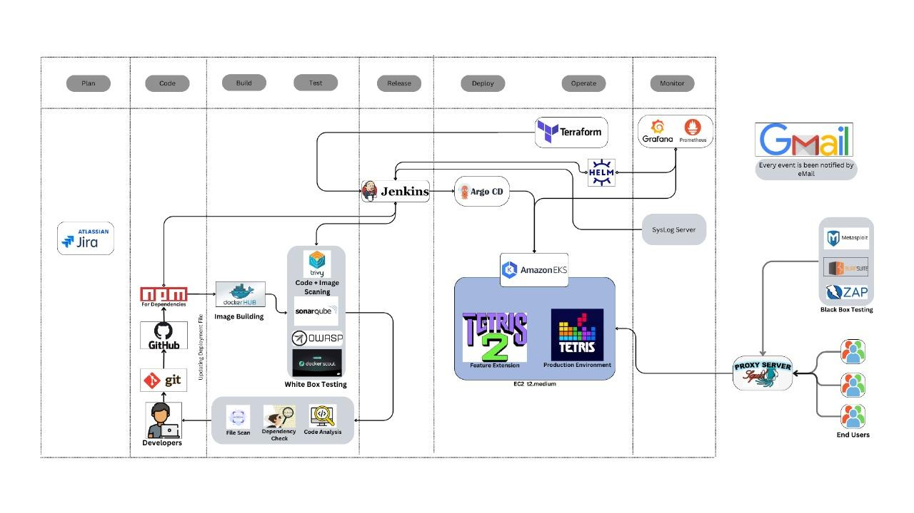

**18 AWS Project** 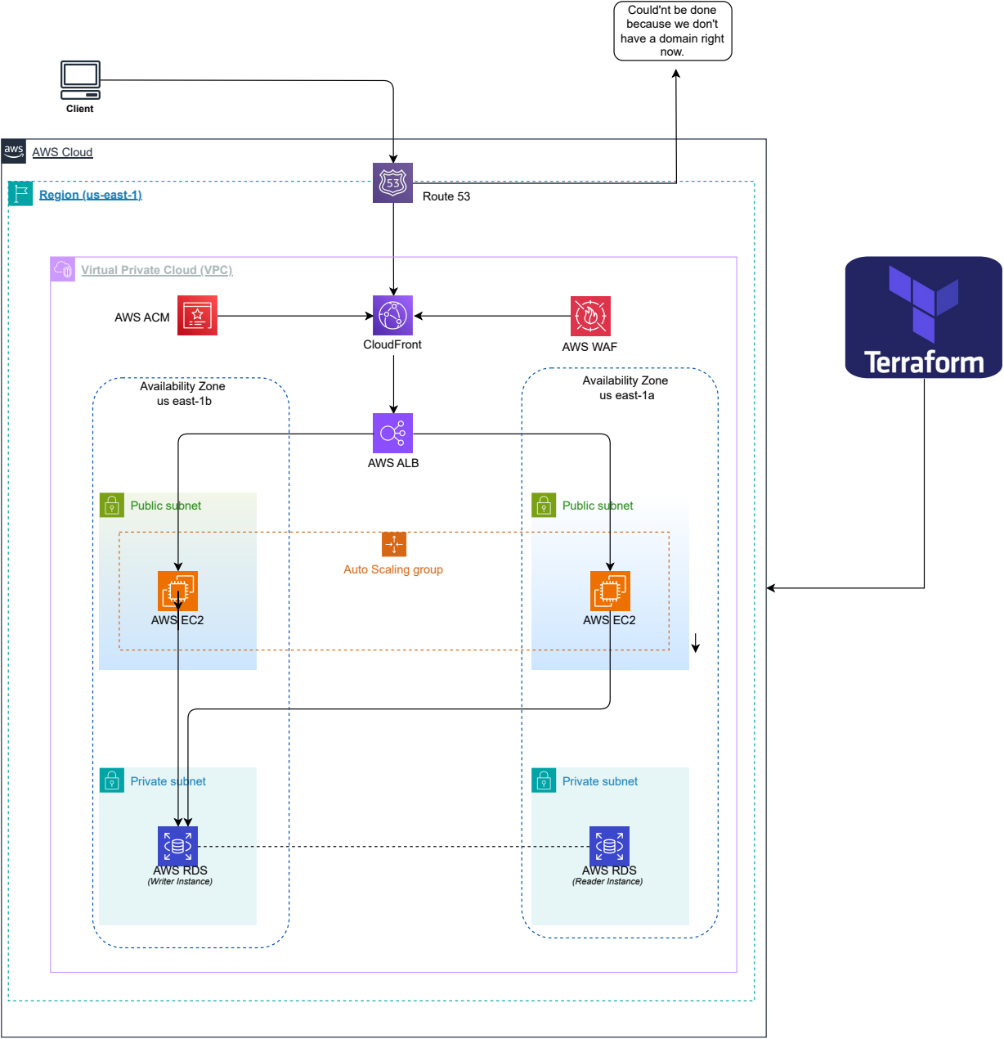

**19 OUTPUT**

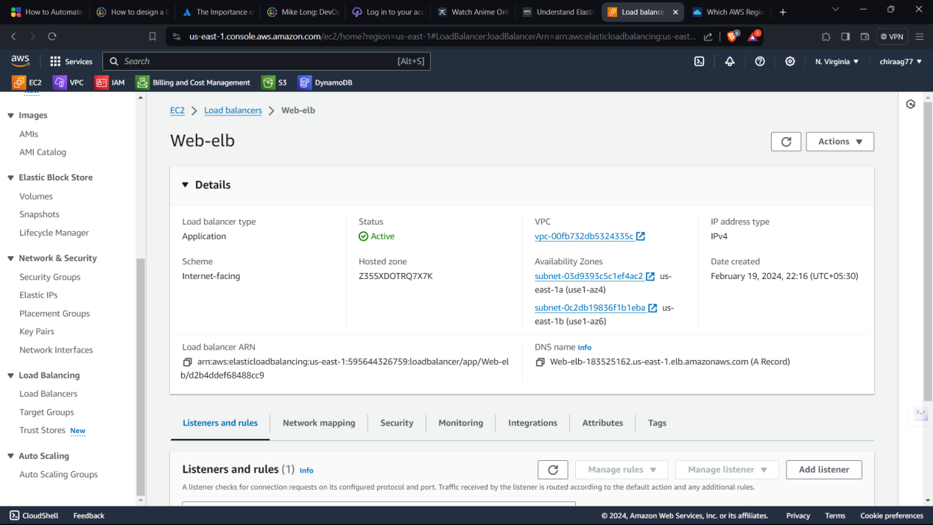

Here we are using web-elb,A Web ELB (Elastic Load Balancer) is a service that automatically distributes incoming application traffic across multiple targets, such as EC2 instances, in multiple Availability Zones, improving the fault tolerance of your applications. It helps to ensure high availability and scalability by seamlessly managing traffic flow.

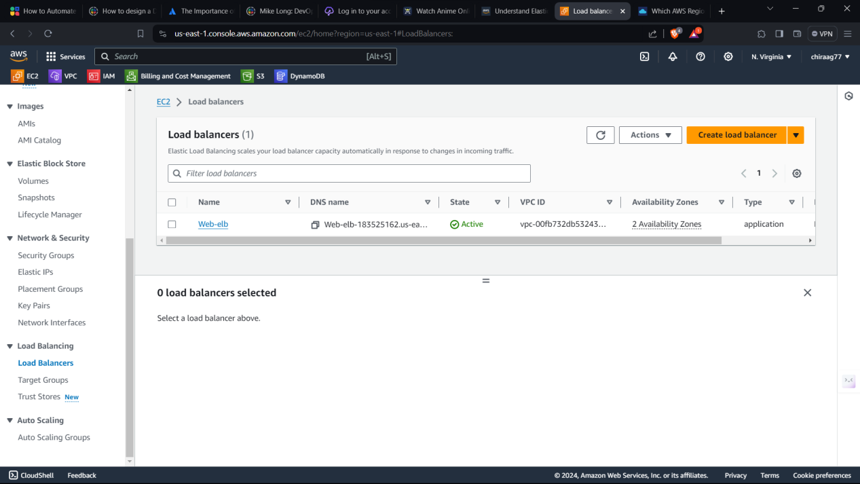

AWS Load Balancer distributes incoming application traffic across multiple targets, such as EC2 instances or containers, to ensure high availability and fault tolerance. It automatically scales in response to incoming traffic and performs health checks to ensure efficient traffic routing. AWS offers different types of load balancers, including Application Load Balancer (ALB), Network Load Balancer (NLB), and Classic Load Balancer (CLB), each suited for specific use cases and traffic types.

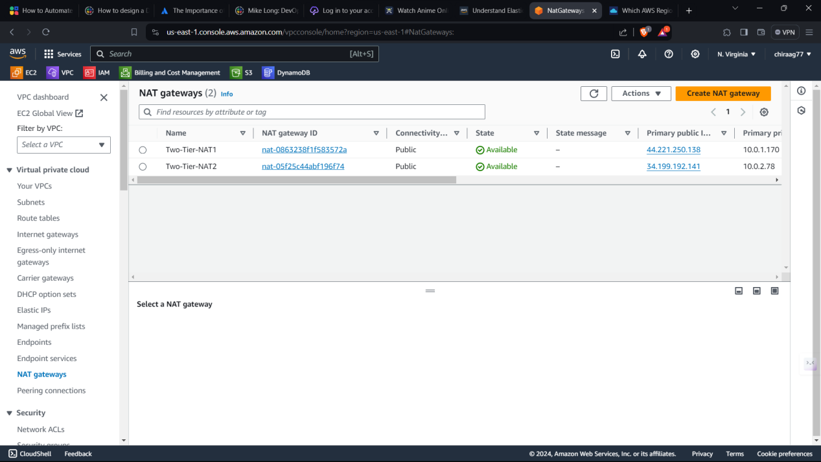

AWS NAT Gateways are managed network devices that allow instances in a private subnet to access the internet while preventing inbound traffic initiation from the internet. They scale automatically based on traffic demand and provide high availability and reliability for outbound internet connectivity in AWS environments.

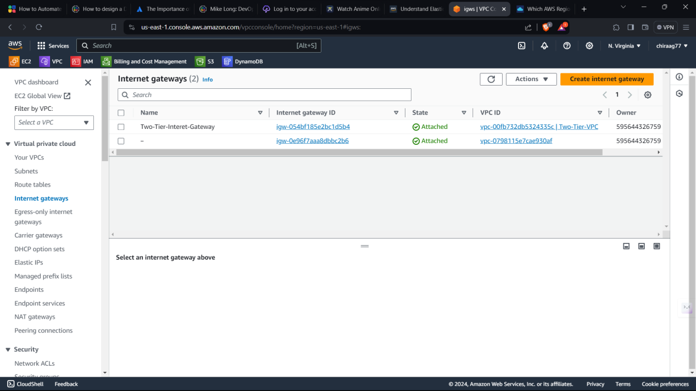

Internet gateways are network devices that facilitate communication between two networks, such as a local area network (LAN) and the internet. They manage traffic, enforce security policies, and enable functions like Network Address Translation (NAT) and firewall protection. Gateways also often support VPN connections for secure remote access and provide logging and monitoring capabilities for network management.

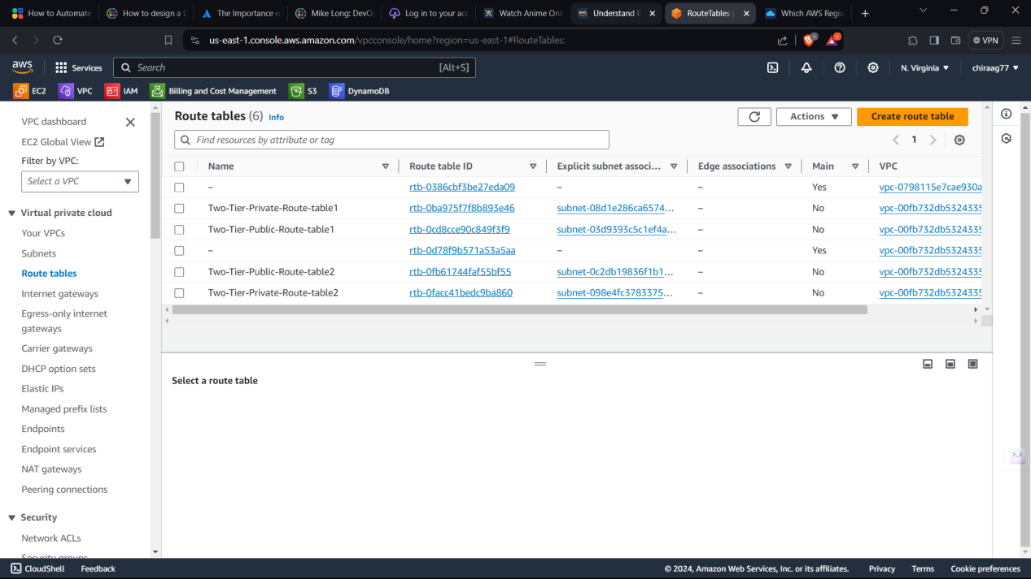

We are using route tables. Route tables are data structures used in networking to determine where network traffic should be directed. They contain information about available paths and their associated destinations, next-hop routers, and metrics such as cost or priority. Route tables enable routers to make forwarding decisions, ensuring efficient data transmission across interconnected networks. They are essential components of IP routing, allowing packets to reach their intended destinations accurately.

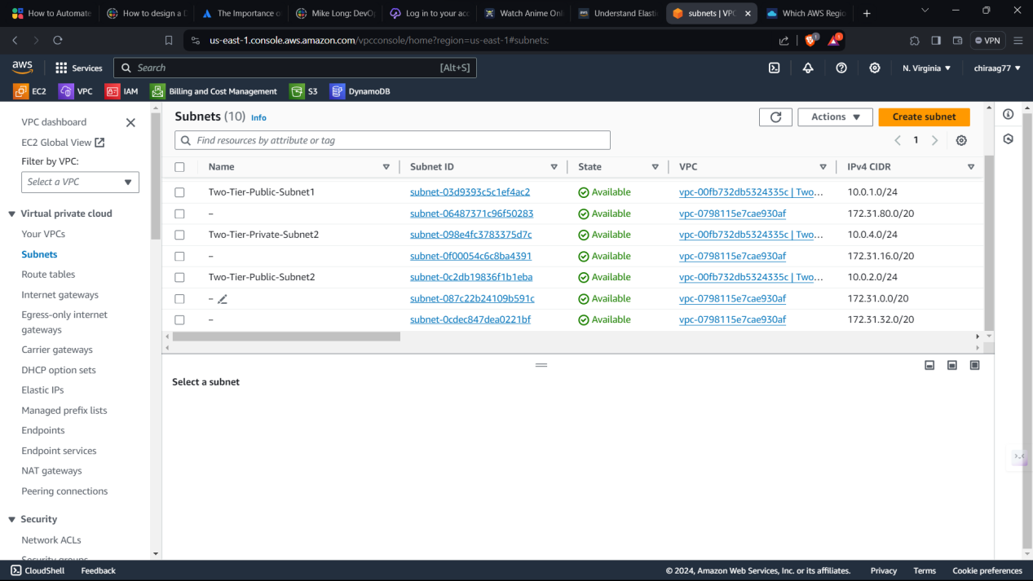

AWS subnets are segmented sections of a virtual private cloud (VPC), allowing customization of network configuration within AWS. They define a range of IP addresses and provide isolation and security for resources deployed within them. Subnets are associated with specific availability zones, enabling redundancy and fault tolerance. They play a crucial role in organizing and managing network resources within the AWS cloud infrastructure.

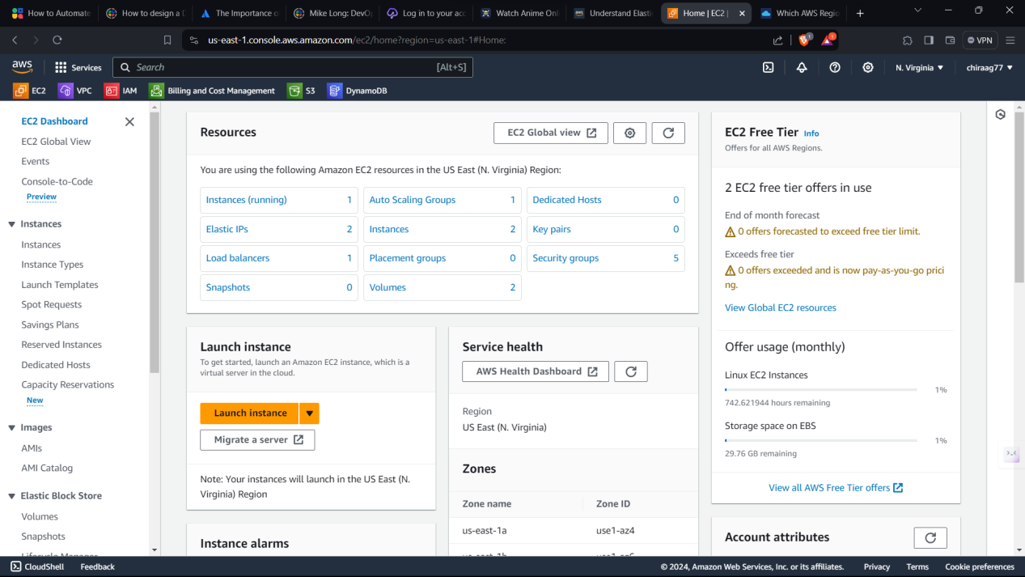

AWS resources refer to the various services and components provided by Amazon Web Services, including computing instances (EC2), storage (S3),networking (VPC), and more. These resources enable users to build, deploy, and scale applications in the cloud, offering flexibility, scalability, and reliability.

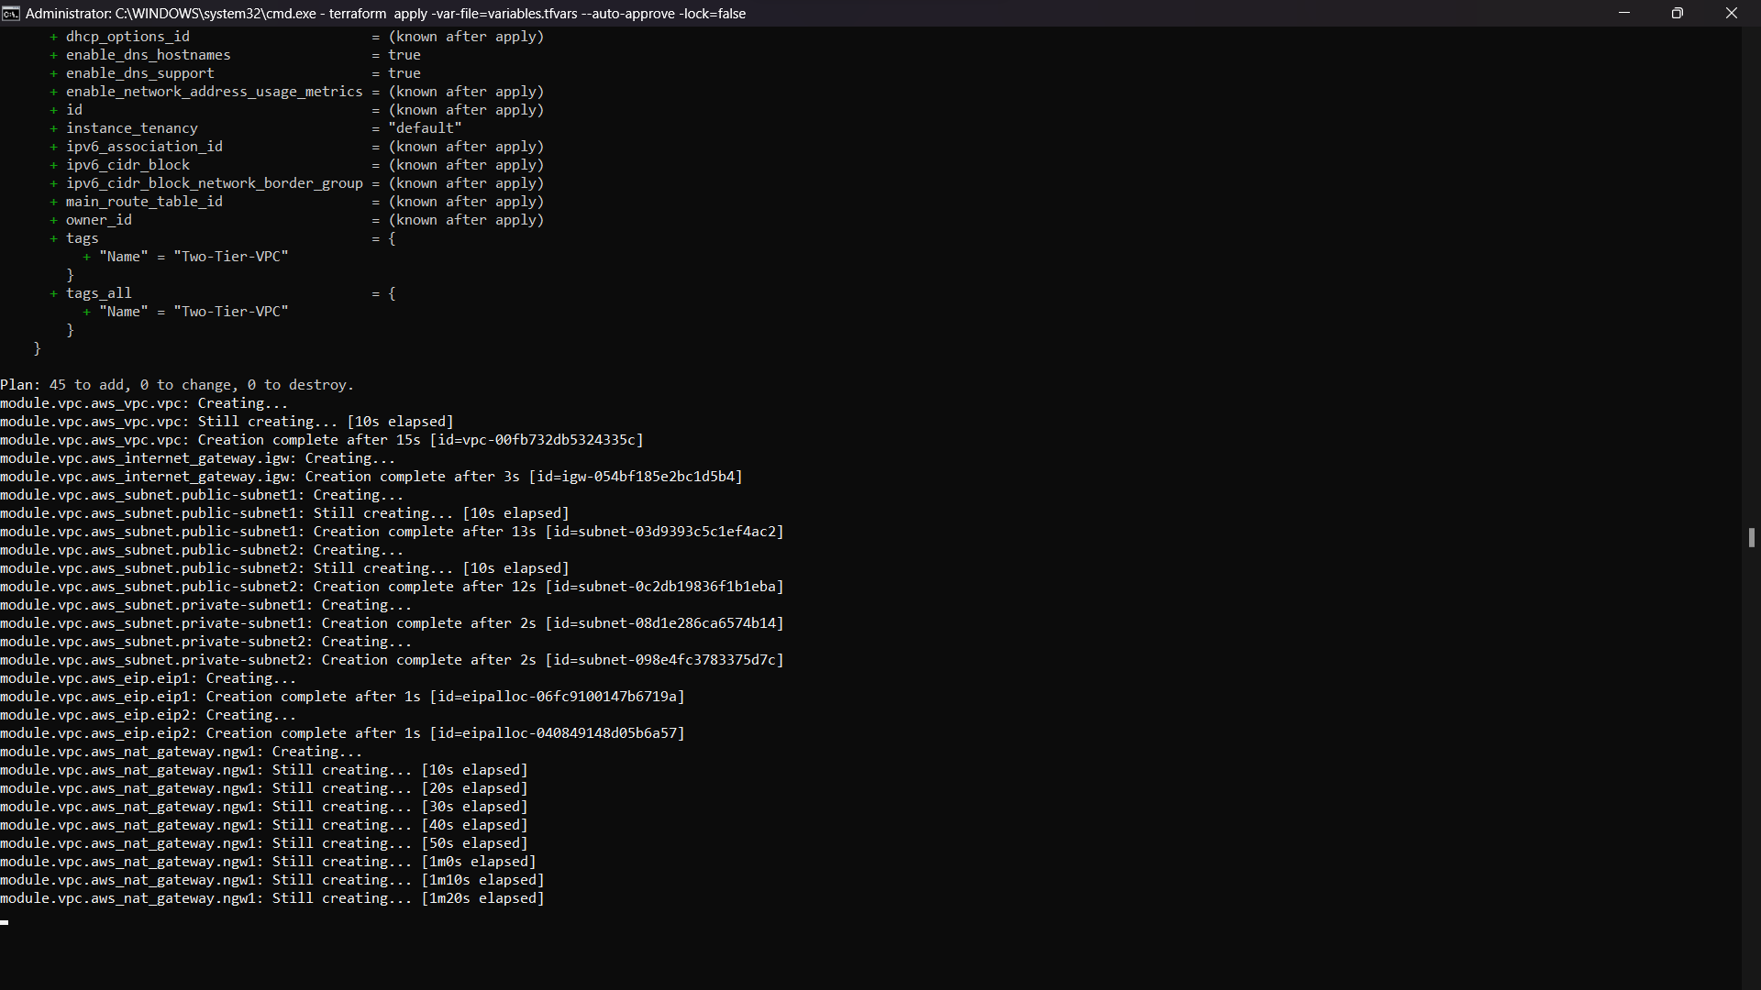

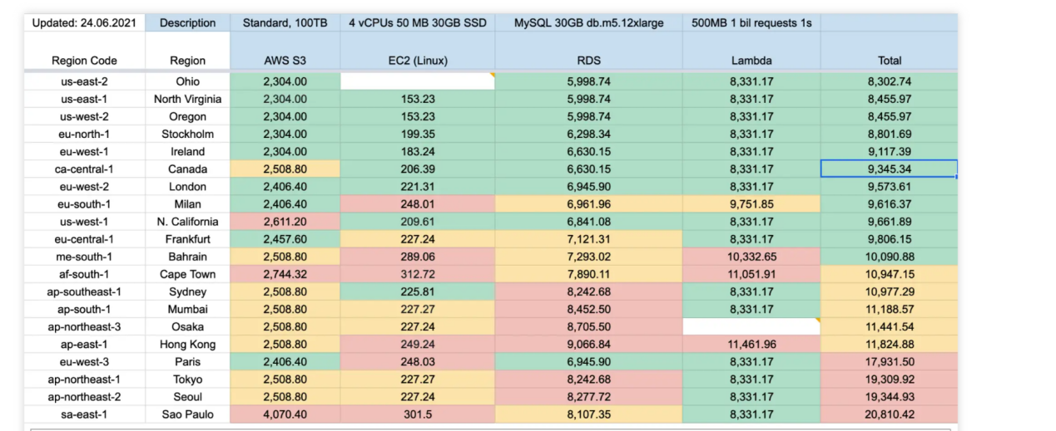

cost estimation

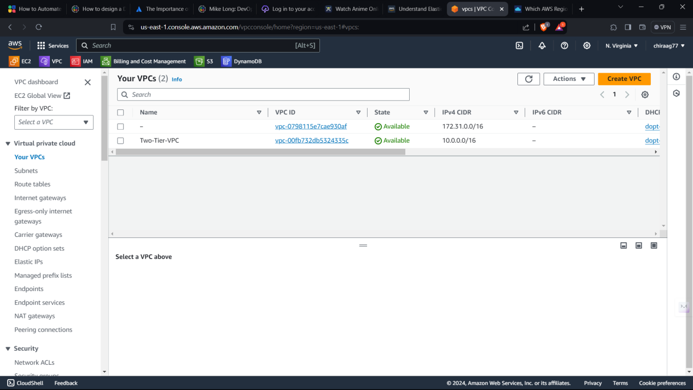

AWS VPC (Virtual Private Cloud) allows users to create a logically isolated section of the AWS Cloud where they can launch AWS resources in a virtual network. Users have complete control over their virtual networking environment, including IP address ranges, subnets, route tables, and network gateways.

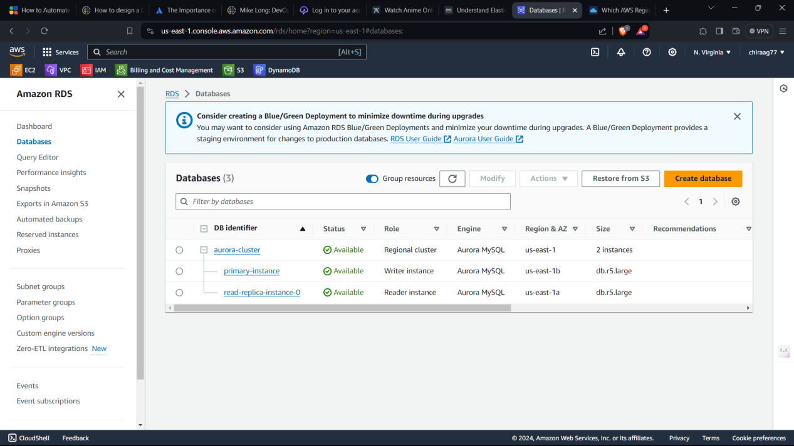

AWS offers a variety of fully managed database services, including Amazon RDS for relational databases like MySQL, PostgreSQL, and SQL Server, and Amazon DynamoDB for NoSQL databases. These services automate administrative tasks like hardware provisioning, setup, configuration, patching, and backups, enabling users to focus on application development.

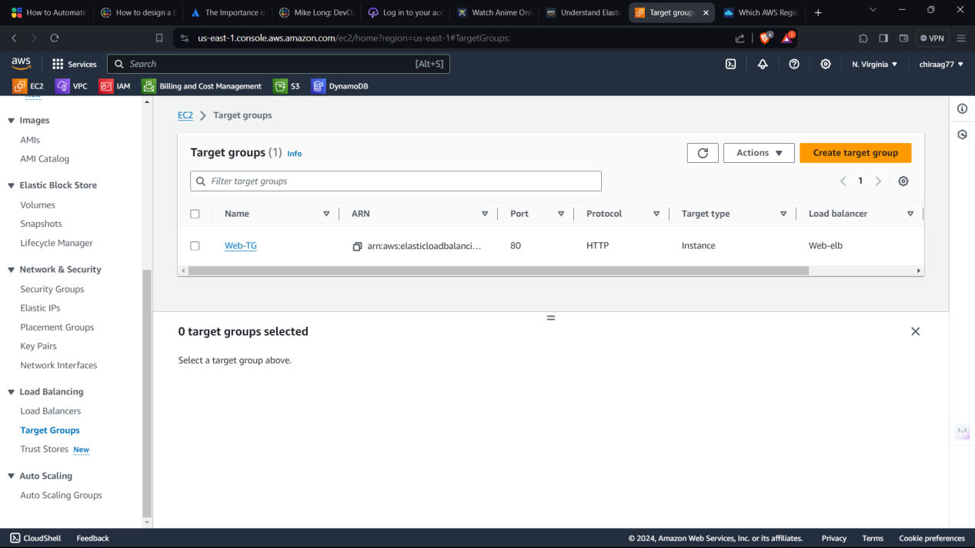

AWS Target Groups are used with the Elastic Load Balancing service to route incoming traffic to instances, containers, or IP addresses based on configurable rules, facilitating efficient distribution and scaling of application traffic. They support health checks and various load balancing algorithms, ensuring high availability and performance of applications deployed in AWS.

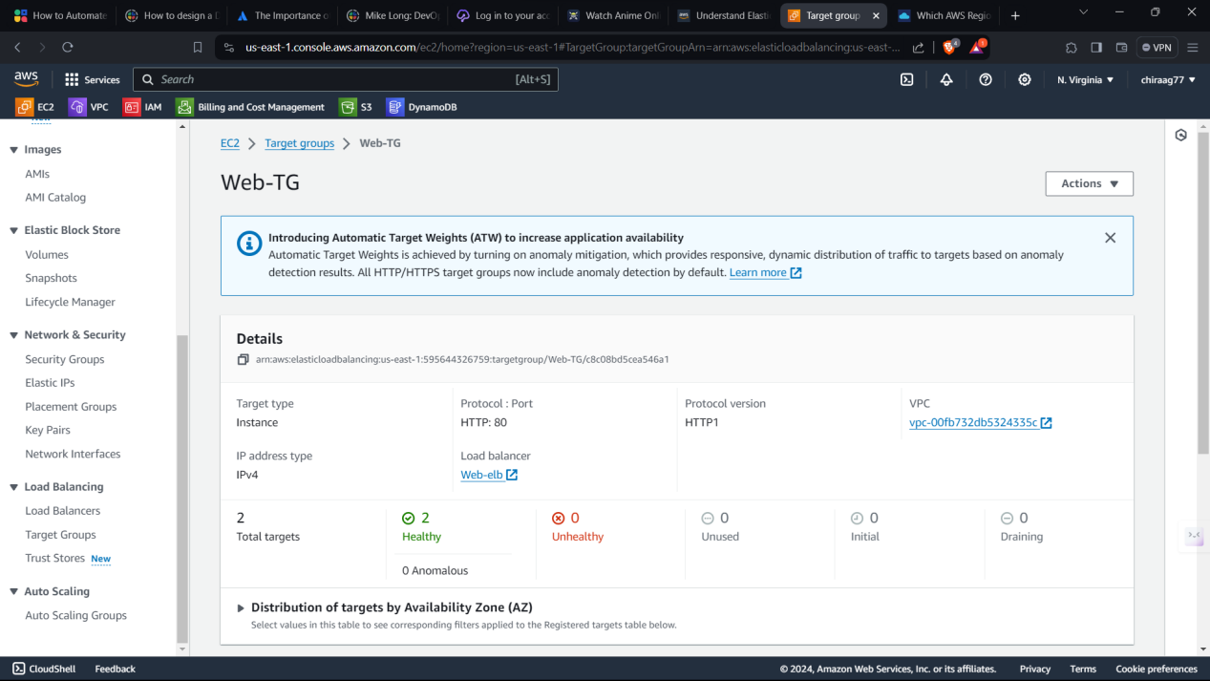

AWS Web Target Groups are specific types of target groups used with the Application Load Balancer (ALB) to route HTTP and HTTPS traffic to targets like EC2 instances or containers based on configurable rules, facilitating efficient load balancing and scaling of web applications. They support features like path-based routing and host-based routing, enabling flexible and granular control over traffic distribution for web applications deployed in AWS.

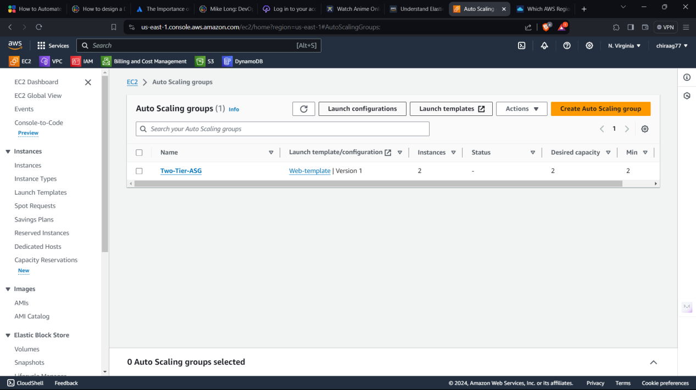

Auto Scaling Groups in AWS automatically adjust the number of EC2 instances in response to demand, ensuring optimal performance and cost efficiency. They help maintain application availability by automatically replacing unhealthy instances and distributing traffic across healthy instances.

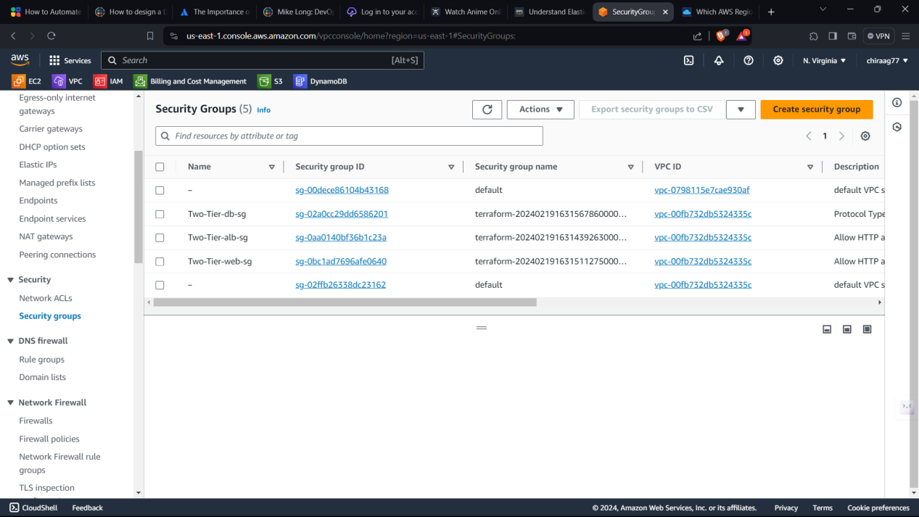

AWS Security Groups act as virtual firewalls for EC2 instances, controlling inbound and outbound traffic based on defined rules. They provide a flexible and scalable way to enforce network security, allowing users to manage access to their instances with ease.

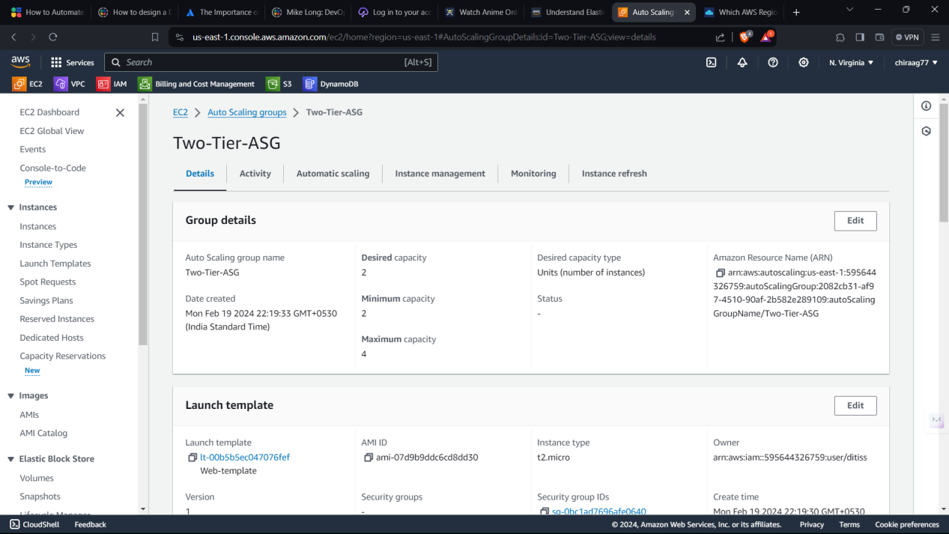

A two-tier Auto Scaling Group (ASG) architecture typically consists of two ASGs: one for the web/application layer and another for the database layer, allowing independent scaling based on workload demands. This setup enhances performance and availability by dynamically adjusting the number of instances in each tier while maintaining separation and scalability for optimal resource utilization.

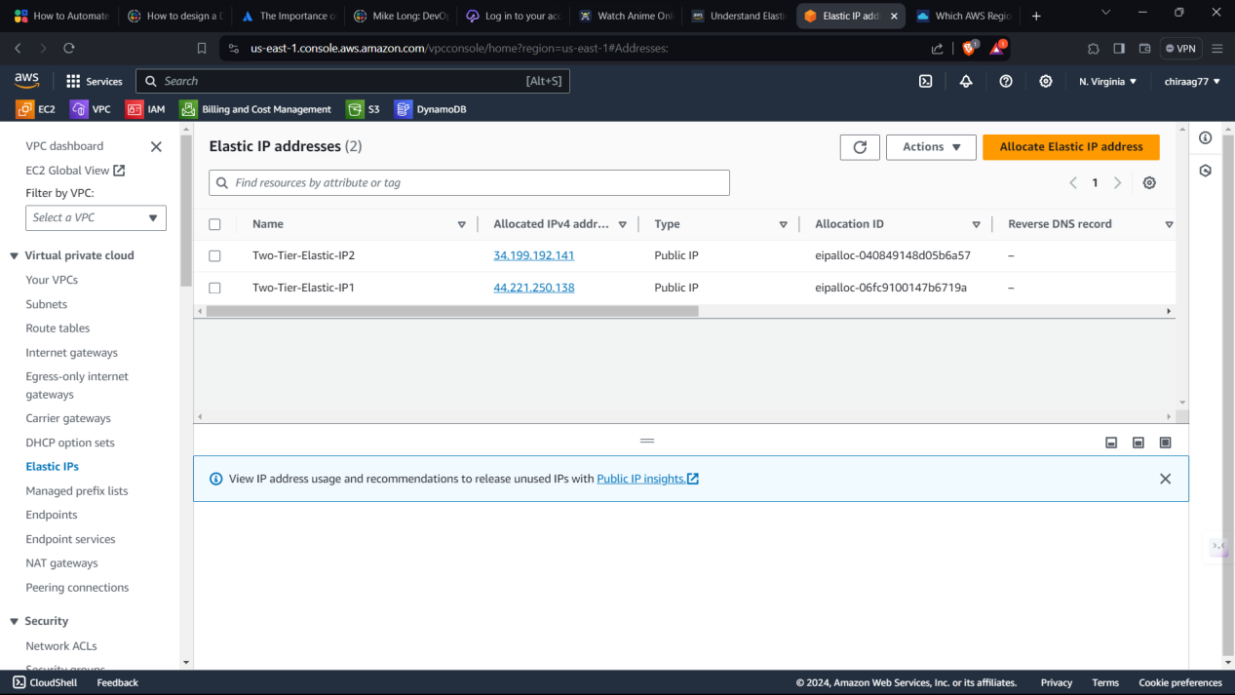

Amazon Elastic IP addresses are static IPv4 addresses designed for dynamic cloud computing within the AWS ecosystem. They provide a persistent, fixed IP address that can be associated with instances, ensuring consistent access even if the instance is stopped or replaced. Elastic IPs facilitate seamless failover and help maintain application availability by allowing quick remapping to different instances in the same AWS region. They are particularly useful for hosting web applications, email servers, or any service requiring a static public IP address within AWS.

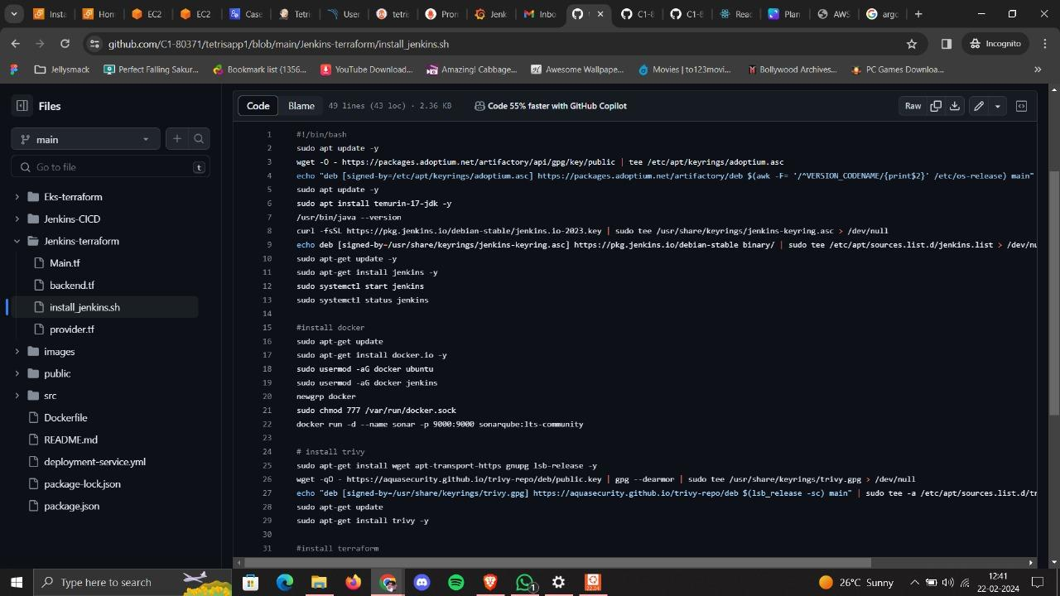

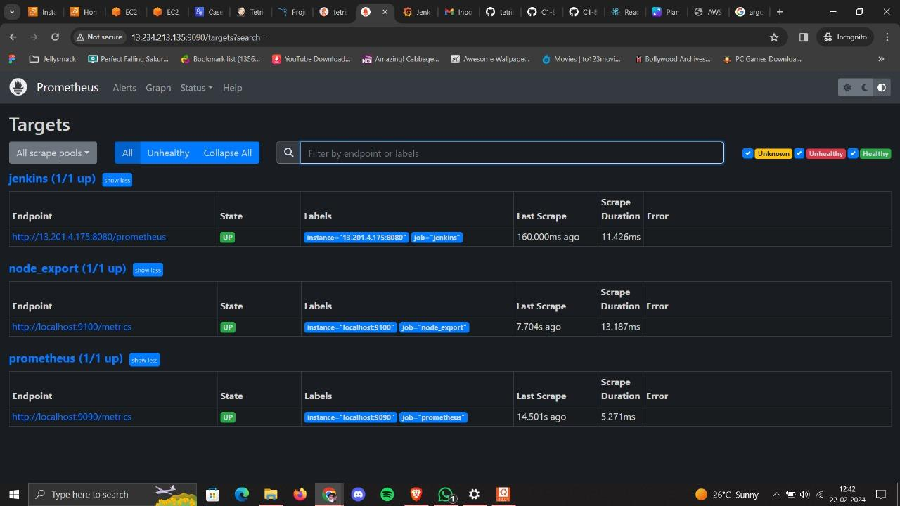

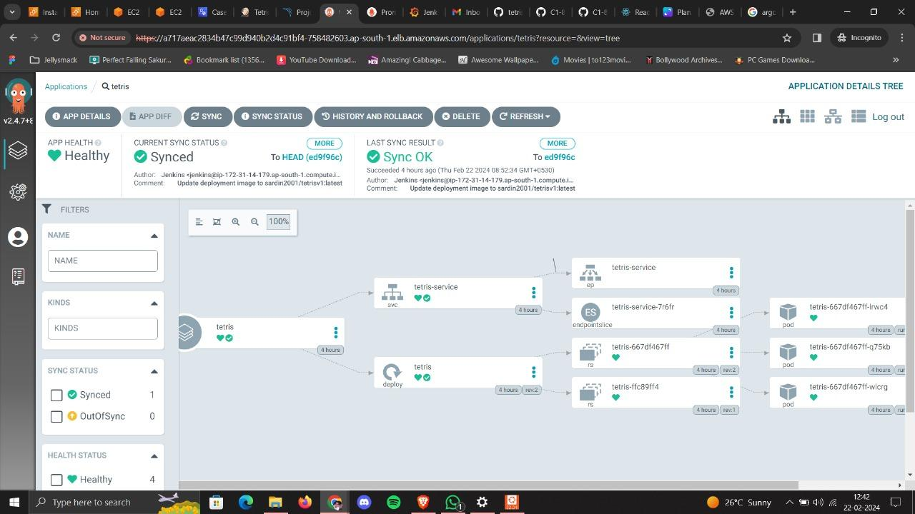

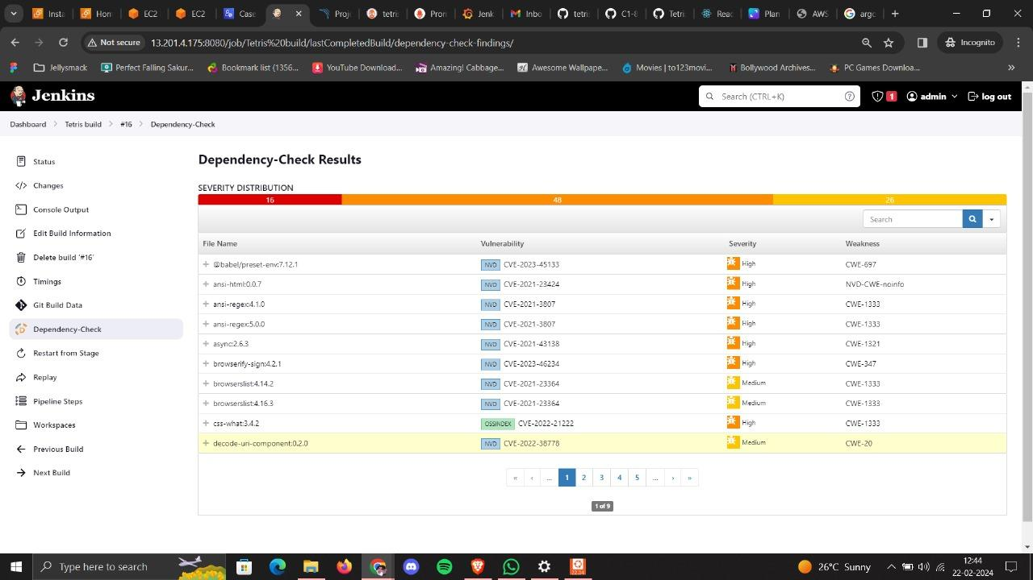

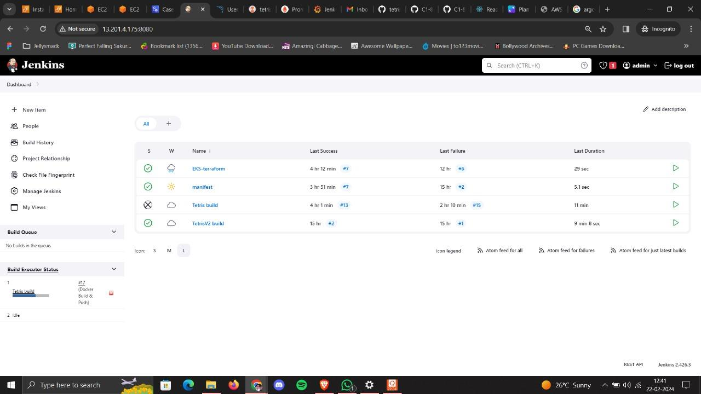

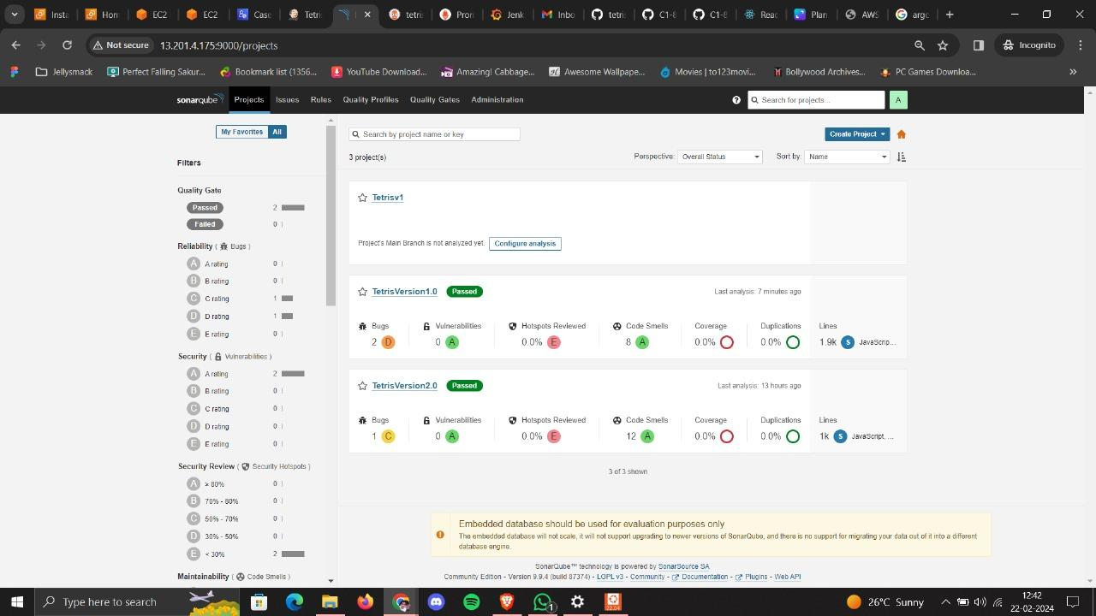

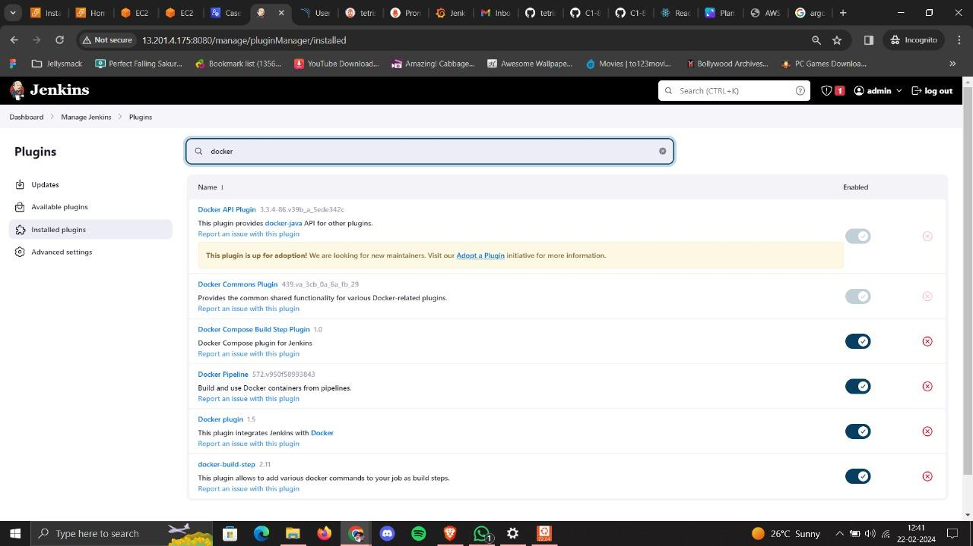

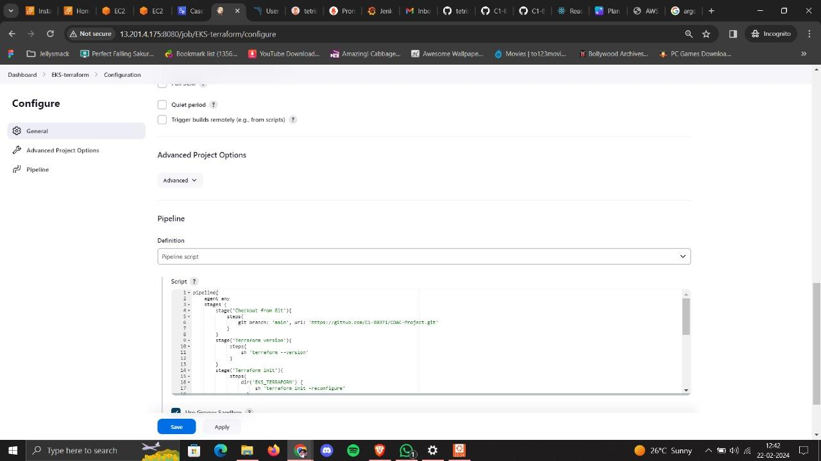

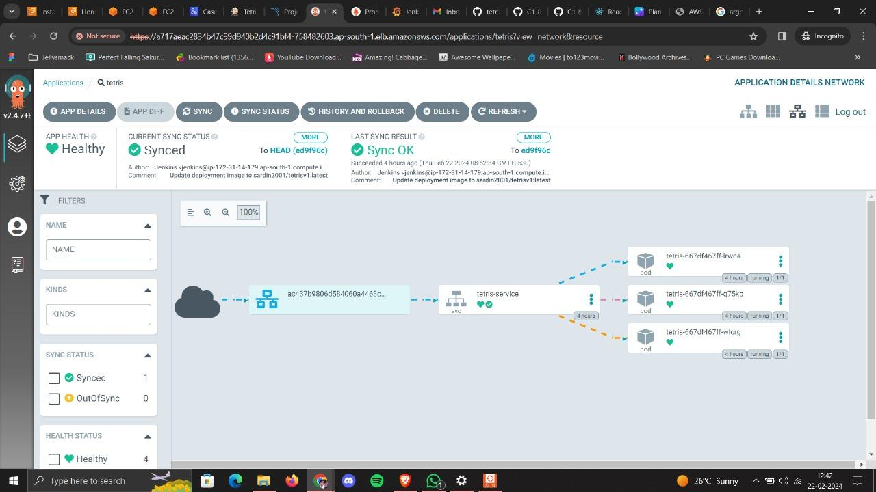

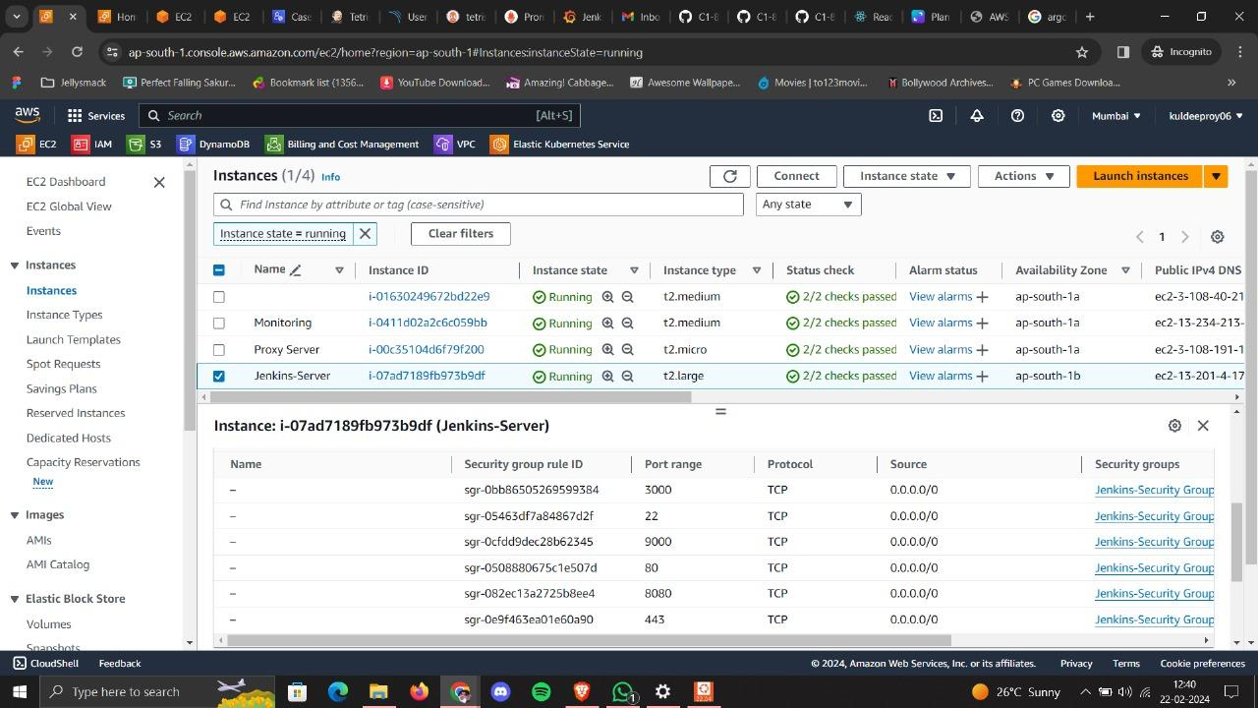

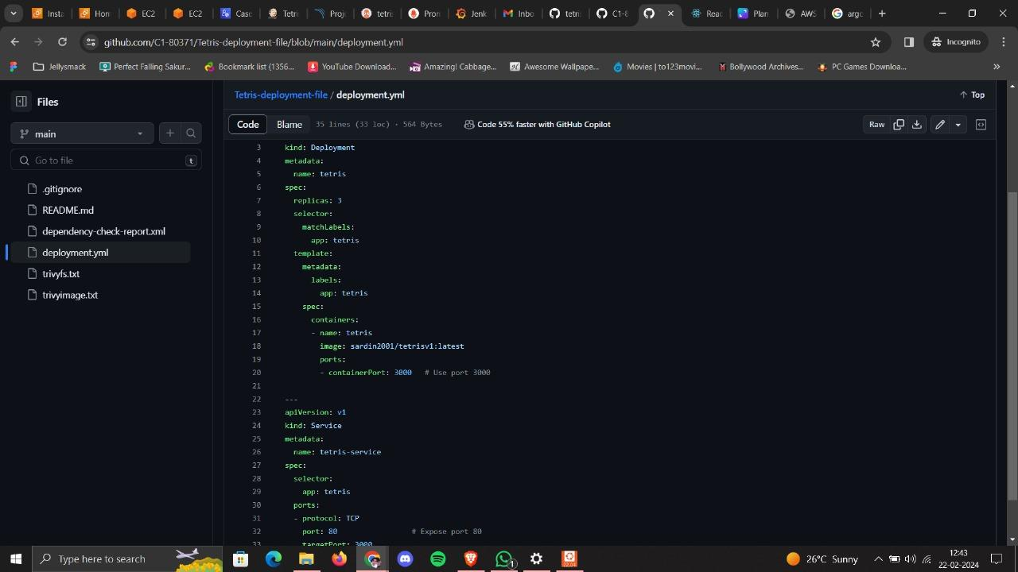

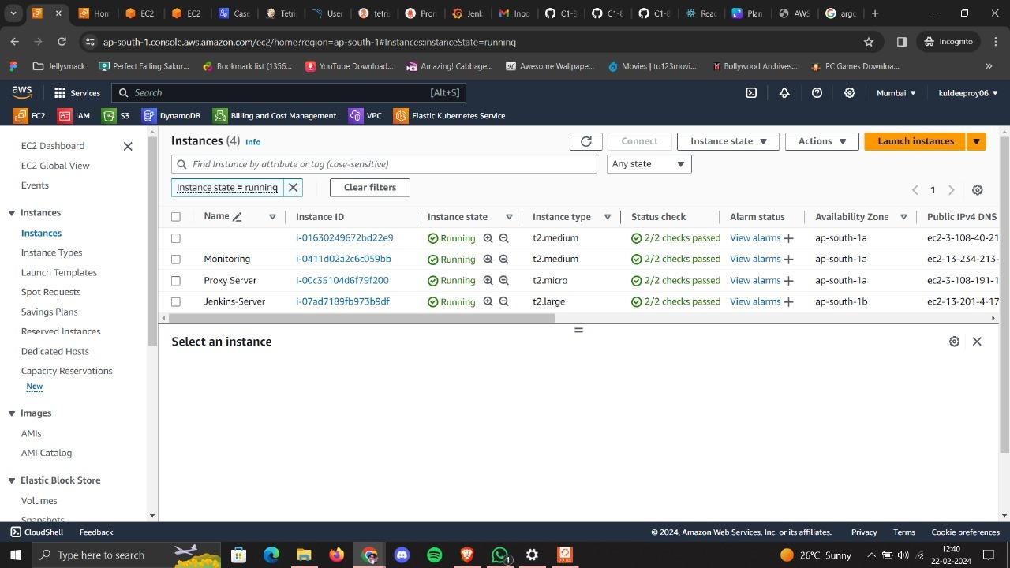

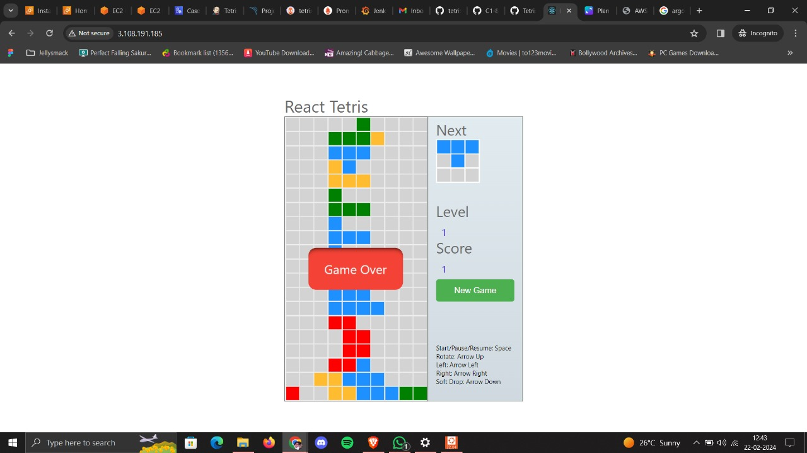



**20. CONCLUSION**

**20.1 Conclusion:**

In conclusion, our project to modernize infrastructure with DevSecOps has been a resounding success, significantly enhancing both the efficiency of our workflows and the robustness of our security measures. By leveraging cutting-edge technologies such as Git, Jenkins, ArgoCD, Kubernetes, Prometheus, Grafana, and AWS-EKS with RBAC, we have streamlined our development processes while ensuring that security remains a top priority at every step.

Our architecture on AWS is carefully designed to maximize performance, scalability, and resilience, incorporating CI/CD pipelines, Amazon Certificate Manager, CloudFront, EC2, Auto Scaling, VPC, RDS, DynamoDB, S3, and CloudWatch. This comprehensive suite of services empowers us to deploy, manage, and monitor our applications with confidence, knowing that they are backed by a highly available and secure infrastructure.

Enhanced security measures, including a zero-trust policy, syslog server, Blackbox testing server, and proxy for comprehensive testing and security, provide additional layers of protection against potential threats and vulnerabilities. By adopting a proactive approach to security, we can identify and address potential risks before they escalate, safeguarding our systems and data against unauthorized access and malicious activities.

Furthermore, our commitment to ensuring infrastructure compliance with industry standards across both cloud (SaaS) and on-premises (IaaS) environments demonstrates our dedication to maintaining the highest levels of security and regulatory compliance. Through rigorous testing, auditing, and monitoring processes, we continuously validate our adherence to industry best practices and regulatory requirements, mitigating the risk of non-compliance and associated penalties.

Finally, the utilization of Terraform-driven Infrastructure as Code (IaC) enables us to build and manage scalable infrastructure with ease, facilitating future growth and adaptation. This agile and flexible approach empowers us to rapidly respond to changing business requirements and technological advancements, ensuring that our infrastructure remains agile, efficient, and future-proof.

In summary, our DevSecOps initiative has not only modernized our infrastructure but also elevated our organization's security posture, agility, and resilience. By embracing a culture of continuous improvement and innovation, we remain committed to staying at the forefront of technology and security, enabling us to drive sustainable growth and success in an ever-evolving digital landscape.

**20.2 Future Scope**

**Future Scope:**

1. Advanced Threat Detection and Response: Enhance security measures by integrating advanced threat detection and response mechanisms. This could involve leveraging machine learning algorithms to analyze patterns and anomalies in system behavior, enabling proactive threat mitigation and rapid incident response.

2. Continuous Compliance Monitoring: Implement automated compliance monitoring tools and processes to ensure adherence to industry standards and regulatory requirements across both cloud (SaaS) and on-premises (IaaS) environments. This could involve the integration of compliance frameworks such as CIS benchmarks and NIST standards into existing workflows, enabling real-time assessment and remediation of compliance issues.

3. Container Security Orchestration: Expand the use of Kubernetes and other container orchestration tools to incorporate advanced container security features. This includes implementing container runtime security solutions, image scanning tools, and network policy enforcement mechanisms to secure containerized applications throughout their lifecycle.

4. Zero Trust Network Architecture: Strengthen the zero trust network architecture by implementing micro-segmentation, least privilege access controls, and identity-based authentication mechanisms. This ensures that only authorized users and devices are granted access to sensitive resources, regardless of their location or network environment.

5. Enhanced Observability and Monitoring: Enhance observability and monitoring capabilities by integrating additional tools such as distributed tracing systems, log aggregation platforms, and application performance monitoring (APM) solutions. This provides deeper insights into system behavior, performance bottlenecks, and security incidents, enabling proactive troubleshooting and optimization.

6. DevSecOps Culture and Training: Foster a culture of security awareness and collaboration across development, operations, and security teams through ongoing training programs, workshops, and knowledge sharing sessions. This ensures that security considerations are integrated into every stage of the software development lifecycle, from design and development to deployment and maintenance.

7. Advanced Infrastructure as Code (IaC) Practices: Evolve infrastructure as code (IaC) practices by leveraging advanced tools and techniques such as GitOps and policy as code. This enables the codification of security policies, compliance requirements, and infrastructure configurations, ensuring consistency, repeatability, and security across all environments.

8. Cloud-Native Security Solutions: Embrace cloud-native security solutions and services offered by cloud providers to augment existing security measures. This includes leveraging native security features such as AWS Security Hub, Azure Security Center, and Google Cloud Security Command Center to gain centralized visibility, threat detection, and compliance management capabilities.

9. Incident Response Automation: Implement automated incident response workflows and playbooks to streamline the detection, analysis, and remediation of security incidents. This involves integrating security orchestration, automation, and response (SOAR) platforms with existing security tools and systems to enable rapid and coordinated incident response actions.

1. Continuous Improvement and Optimization: Continuously evaluate and optimize security measures, infrastructure configurations, and operational processes through regular security assessments, penetration testing, and performance tuning exercises. This ensures that the infrastructure remains resilient, compliant, and capable of supporting future growth and adaptation initiatives.